In this package:
Metrix Navigation
Getting Started Tutorial
Step 1: Career Pathways
Step 2: Browse the Catalog
Step 3: Find a Job
Extras: Browse the catalog
certification tracks
my plan
3 Apps

Administrator Tools
Creating user accounts
self-directed registration
user wizard
Batch upload

Reports
case management report
admin/monthly report
User Registration Detail Report
Group/Department Reports

Common support
edit user functions

Metrix Navigation
getting started tutorial
The Getting Started tutorial reviews the 3 key Metrix features, and is written out on the following pages of this Guide. It may also be viewed on YouTube: https://youtu.be/ml_EIgBtHH0
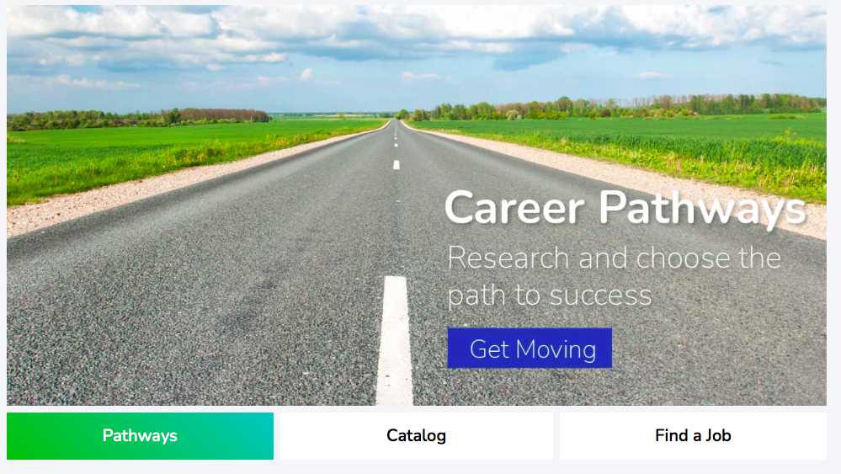
Find tutorial in Metrix:  The first time anyone logs in, the tutorial will appear in a pop-up window: | Tutorials are also located beneath the Help tab:
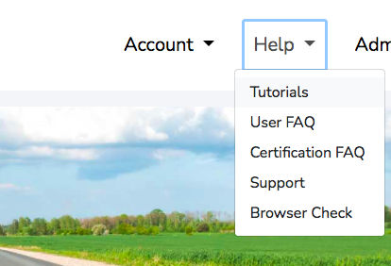
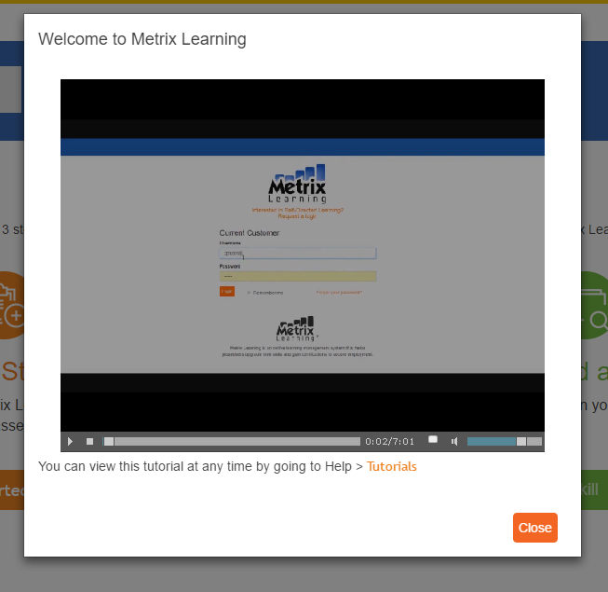

The Career Pathways Tool

Metrix Learning offers 3 key features. The first is the Career Pathways tool. This step allows you to target any of 200 different occupations and receive a recommended learning plan based on the skills required. You may also select the Entry-Level Pathways to work on developing soft skills. Here’s how it works:

- You will initially be brought to a list of generic skills. Rate your proficiency in at least 25 of the skills, then click “Back to Pathways” to proceed.
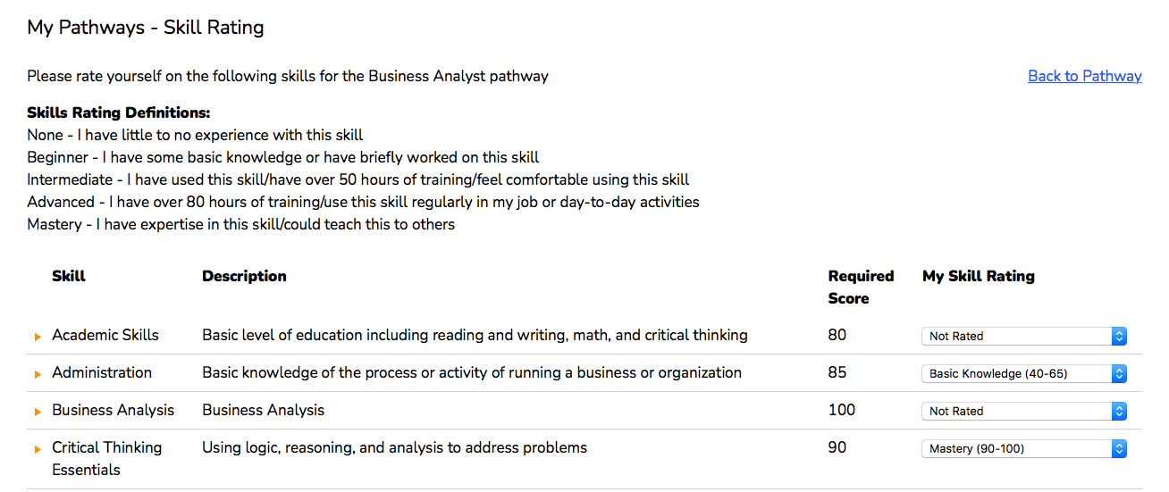
ii. This is the Career Pathways Tool. First, select a target industry, then a goal occupation.
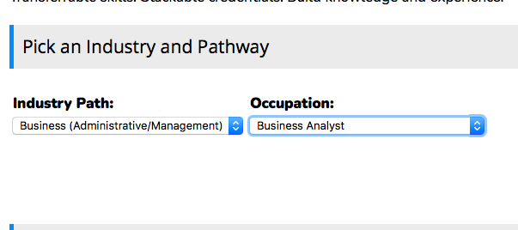

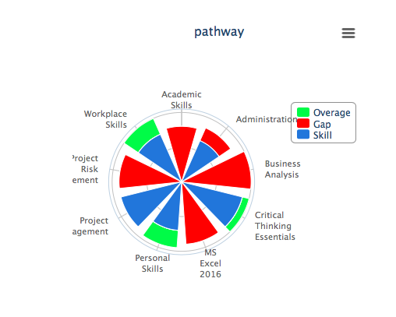

iii. Based on the answers you submitted in the self-assessment, a wheel will populate identifying the skills associated with your goal occupation, and how you’ve rated yourself. Blue and green indicate that you either meet or exceed the skill requirement, while red indicates a skill gap. If you notice any blank skill areas, this means that you had not initially rated yourself in the skill. You can do so at any time by clicking on the “Rate Skills” button.
iv. Skills are categorized at 4 progressive levels: Foundation> Industry> Sector> and Occupation. As you take training to remediate your skill gaps, your progress will be updated in the table on the right. Scroll down the Metrix page to review the recommended learning plan.

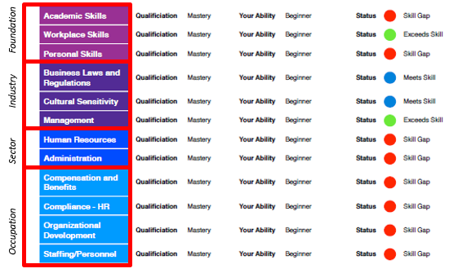

v. Skills are listed in progressive order, and their colors correspond to their skill level. Click on the skill title to see all associated courses. When you’re ready to begin, click on the “Add to Plan” link to the right of the course. Once the course has been added, you can launch the course directly from the Career Pathways Tool by clicking “Launch”.
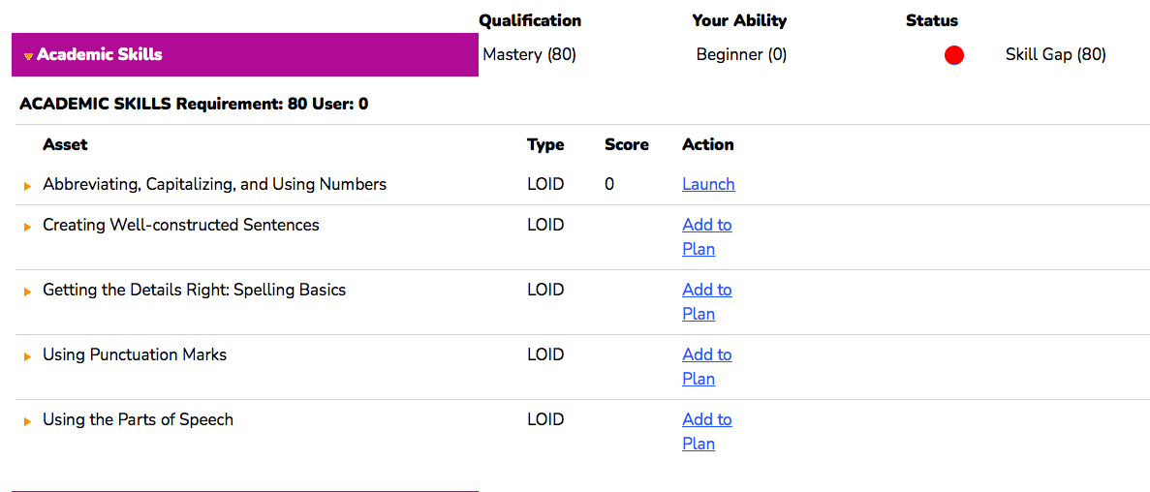

As you remediate your skill gaps, you’ll notice your red areas updating to blue or green.

Catalog

The 2nd Metrix feature will direct you to search the catalog. You can also access the catalog by clicking Catalog > Browse in the top navigation bar, or “Search” in the navigation bar. You may search for activities by keyword, filter between course providers, type of course (mobile ready), length of the course, or by content provider or language (English, Spanish, or Mandarin Chinese).
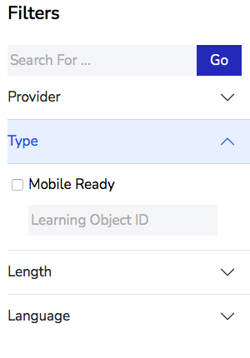
Use the keyword box to enter a topic like Word 2019, then click Go to see the different resources Metrix has to offer. To learn more about a course, click on its title, and then add it to your My Plan.

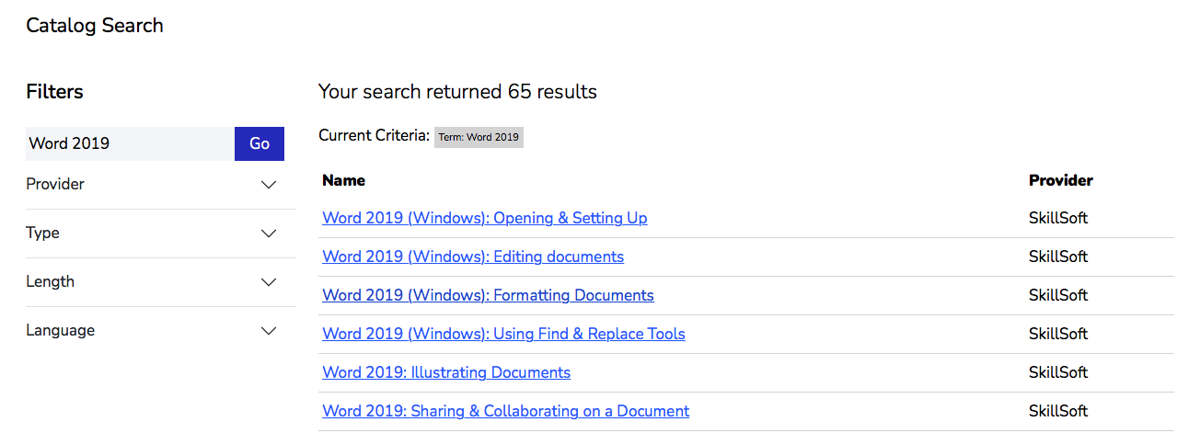

FIND A JOB
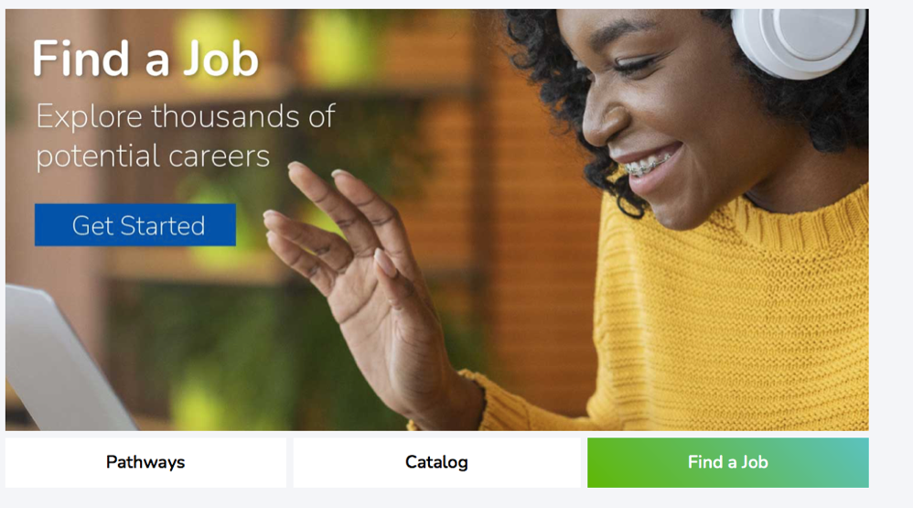
The 3rd Metrix feature provides a direct link to Indeed.com, the most popular job search tool.

Type in a goal occupation or skill to find local demand. Then, click on Search Jobs to search.
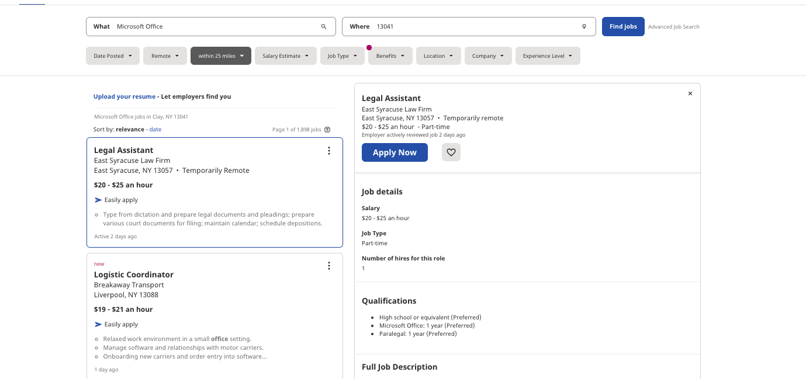

EXTRA TOOLS Skill Tracks
Skill tracks are bundled groups of courses that focus on a specific skill.
The Skill Tracks page in Metrix organizes skills into categories and allows customers to add an entire course bundle to their learning plan in one step. You can choose from over 300 skills to work on. Completion of an entire skill track results in a digital badge, which can be used to boost your resume and professional profiles, like LinkedIn.

To add a skill track, click the “Add to my plan” link located on top of the track.
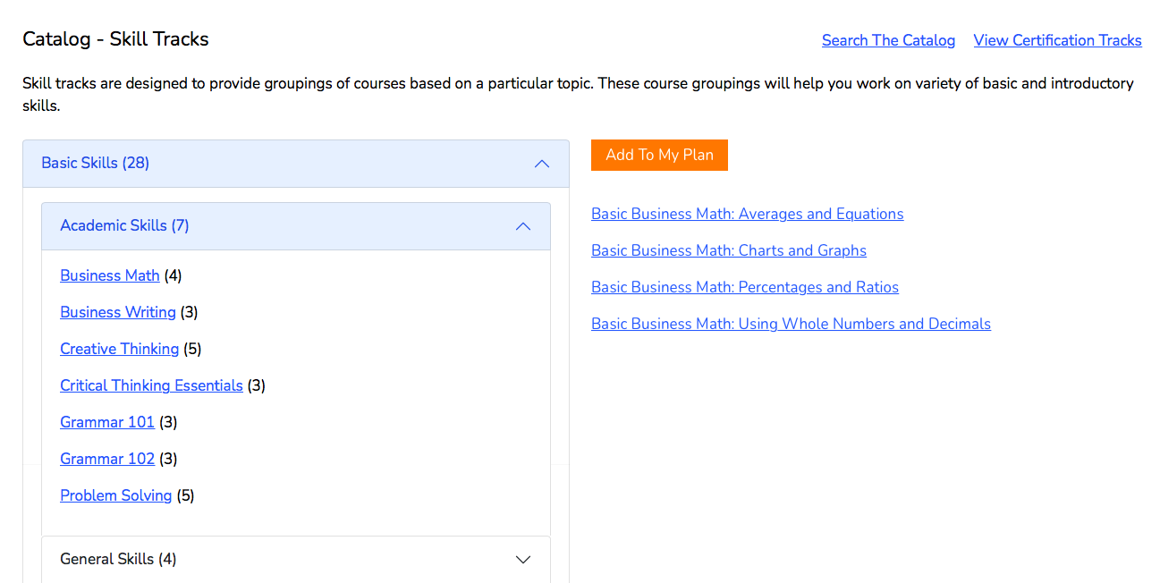

Certification tracks
The last way to browse for courses is by certification track, option 2 beneath the Catalog menu.

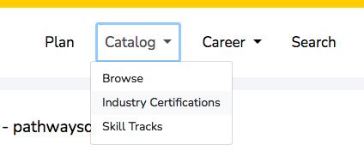

Divided into 3 categories, Business, Desktop, & IT, the certification tracks can help you prepare for over 100 industry recognized certifications including Microsoft Office Specialist, Project Management Professional, and CompTIA.
Completing a certification track does not mean that you are certified. However, certification tracks are intended to provide all-inclusive training to help an individual fully prepare for the real exam. 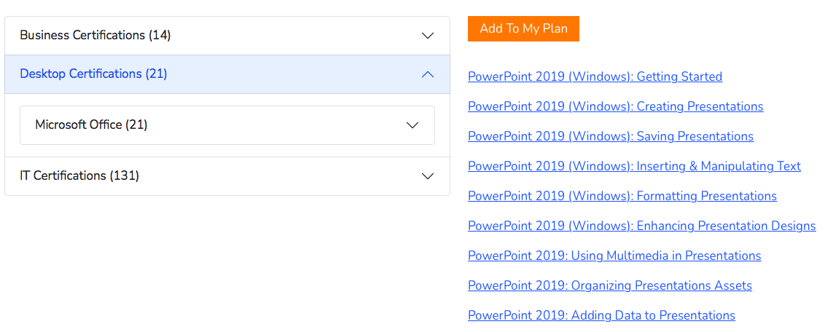

my plan
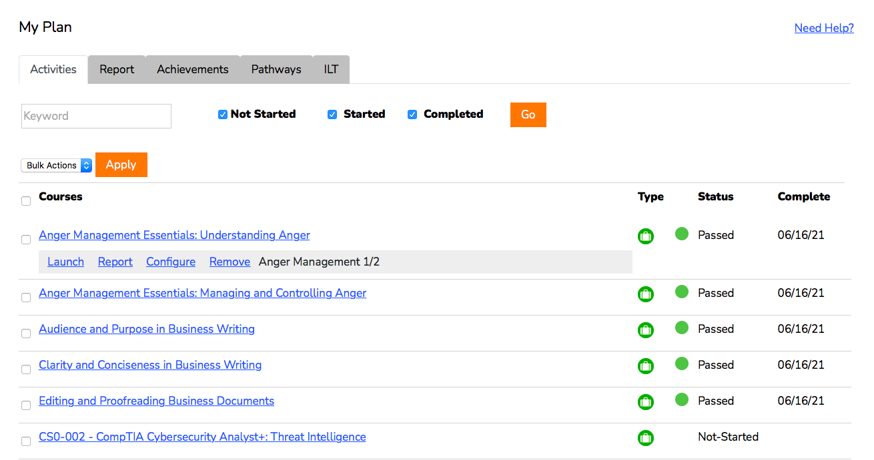
Once you’re ready to begin courses, go to your “My Plan”. The My Plan is where you track and manage the courses you’ve decided to take. Every course you add, whether through the career pathways tool, skill tracks, certification tracks, or the catalog, will be stored here.
Filter by course status
Launch

The track name next to a course lets you know if the course is included in a certification or skill track.
To start a course, click on the name of the course, or click launch. The course will then appear in a separate window. Once a course is launched, you will notice your Status update to Started with an orange bubble. A minimum score of 80% is required to pass a course. The system may require up to 24 hours to update your progress. Once updated, your course status will reflect a Completion and you will have immediate access to your course certificate when you click on the PDF icon. To delete courses from your My Plan, click ‘Remove’.
You can also filter your My Plan for Not Started, Started, and Completed courses by clicking on their corresponding check boxes. The keyword search filter allows you to look up a specific course or assigned track

You can toggle between your My Plan and My Report pages using the navigation tabs above your My Plan.
My Report
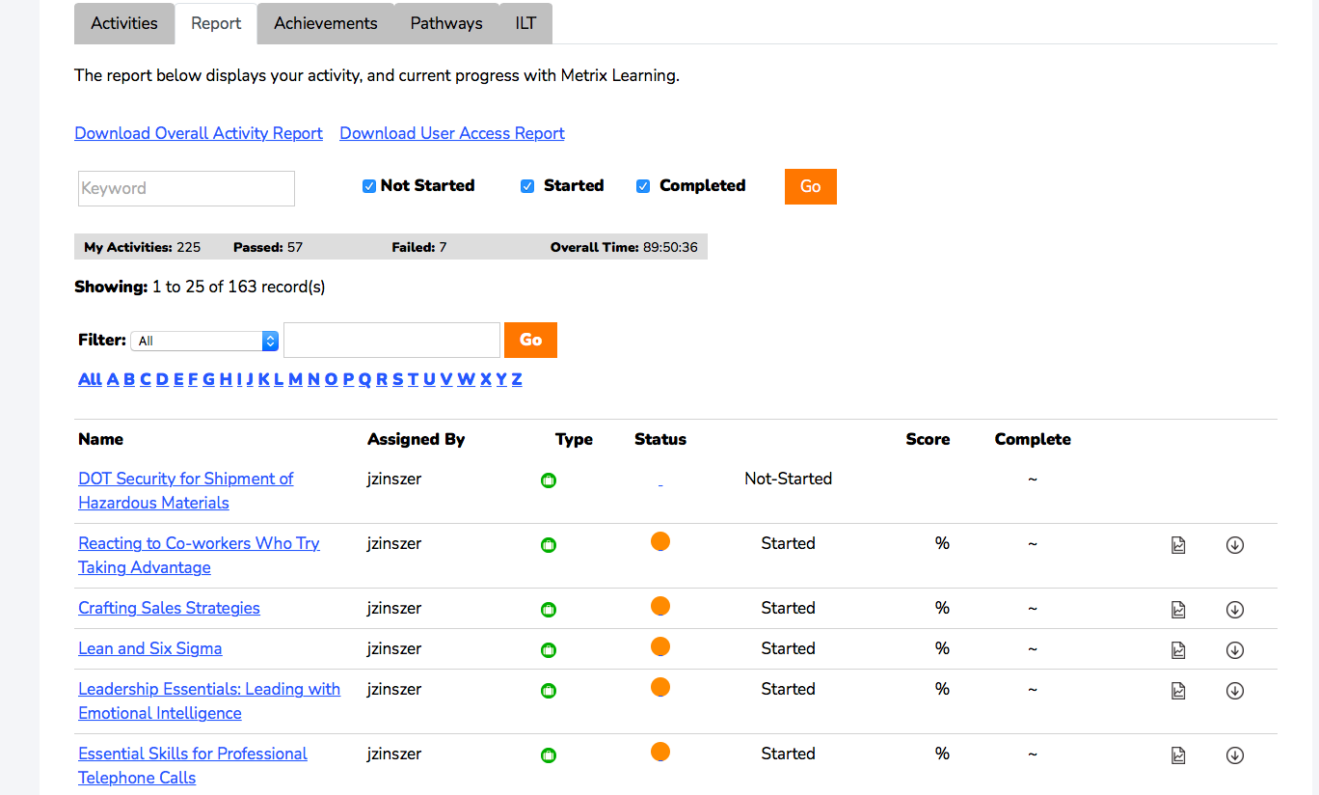

“My Report” will display a summary of the courses and hours you’ve completed in Metrix, as well as details of your progress within each course. Your report can always be exported into an Excel spreadsheet when you click “Download Overall Activity Report” at the top of the page.

Achievements
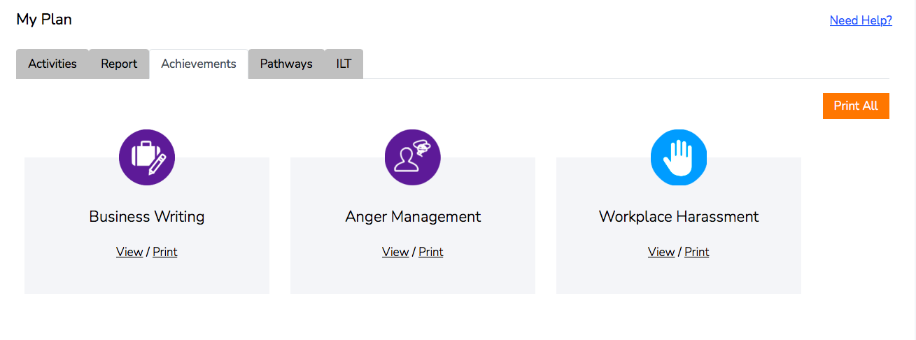

The achievements page shows all badges earned for a specific account. Badges are earned from passing and completing each course in a Skill Track. Users can view or print their badges by clicking on ‘View’ or ‘Print’ under the badge name.

Pathways
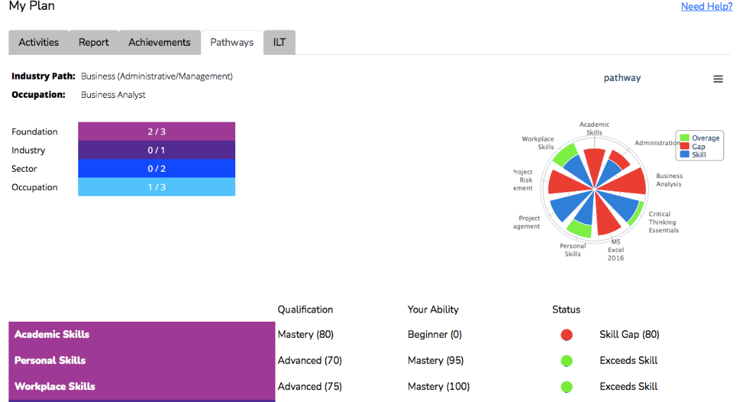

Clicking on Pathways shows the selected pathway and progress for each user.

Creating User Accounts

- self- directed registration
Customers may sign-up for Metrix Learning with your organization’s specific URL. In Portland, they must have a My WorkSource account.
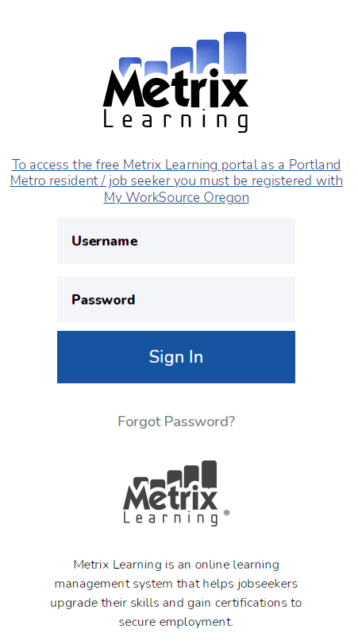
Once submitted, Metrix Learning account will be created with 180-day access to Skillsoft catalog (business, desktop, IT, professional development). Registrant will receive log-in information via email.

- user wizard

On YouTube User Wizard: https://www.youtube.com/watch?v=NTxTjKWwWxA
Metrix administrators can manually create individual user accounts through the User Wizard. There are 5 steps:
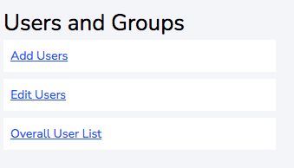
Click “Add Users” button on your dashboard, or go to Administration menu> Users & Groups
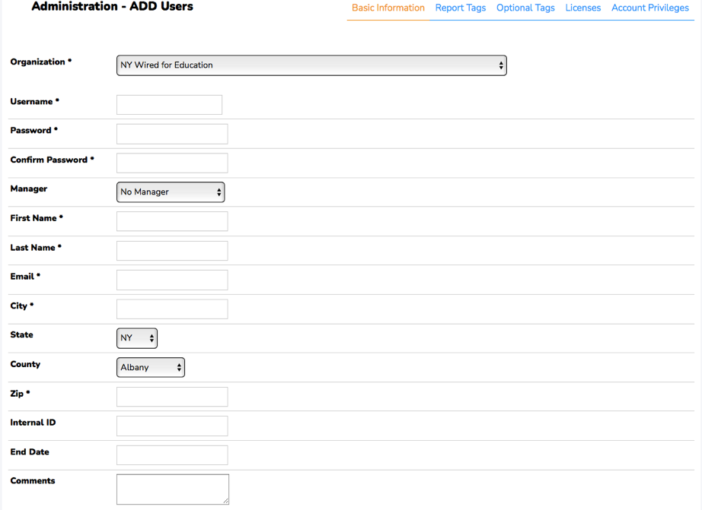
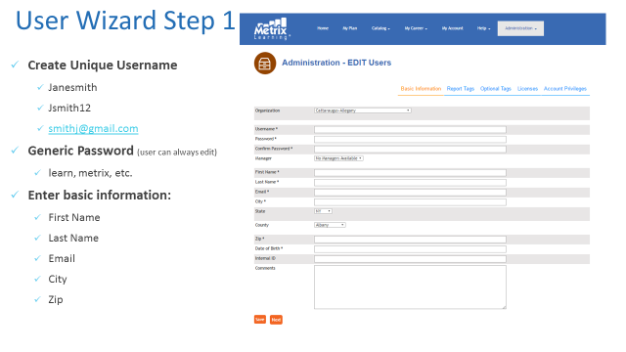
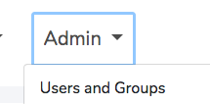
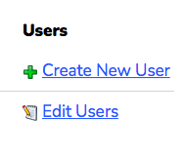
+
OR

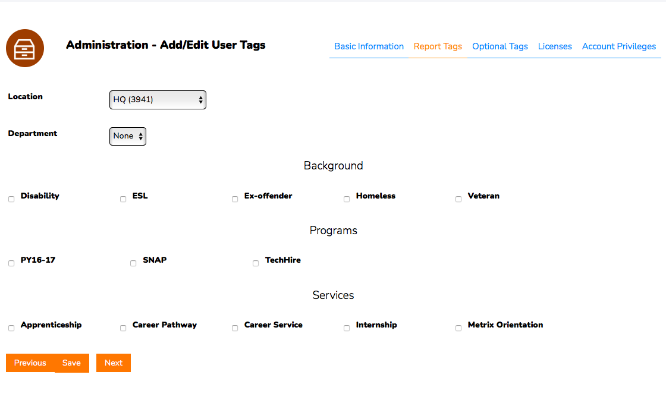

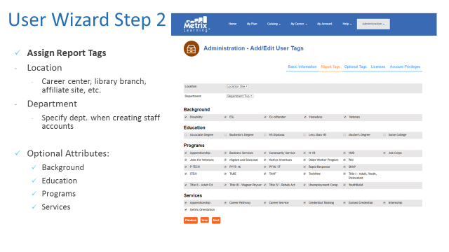

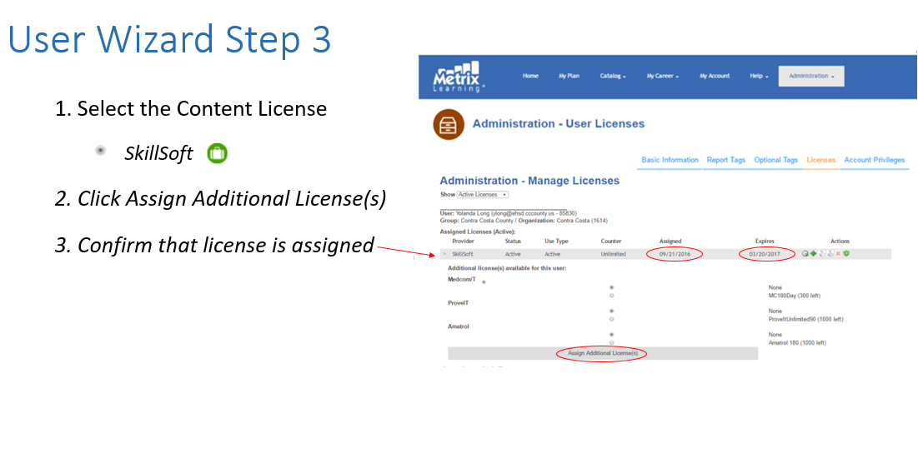

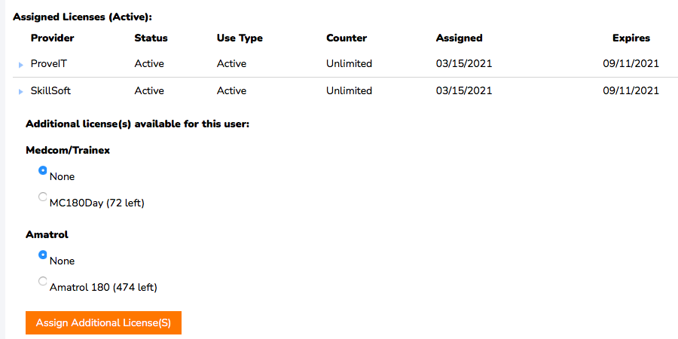

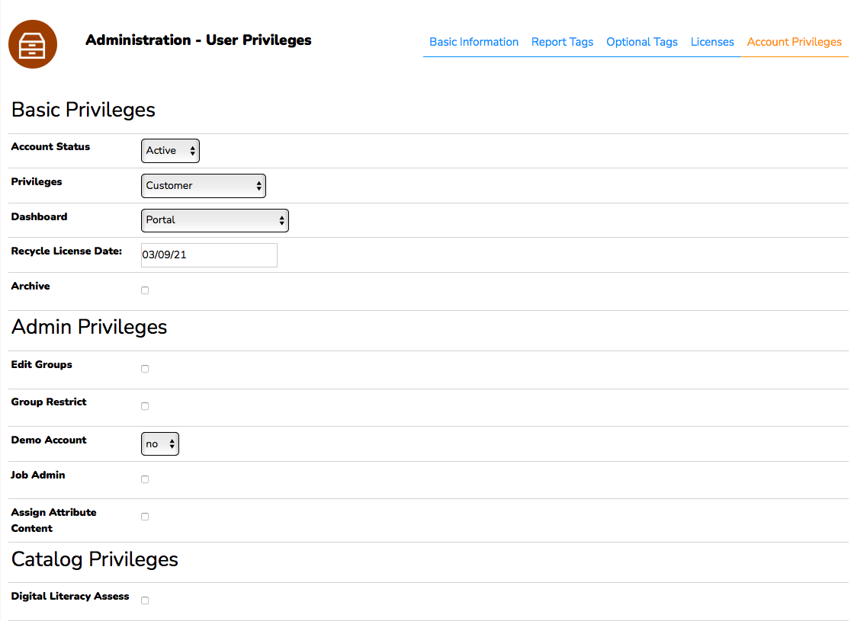
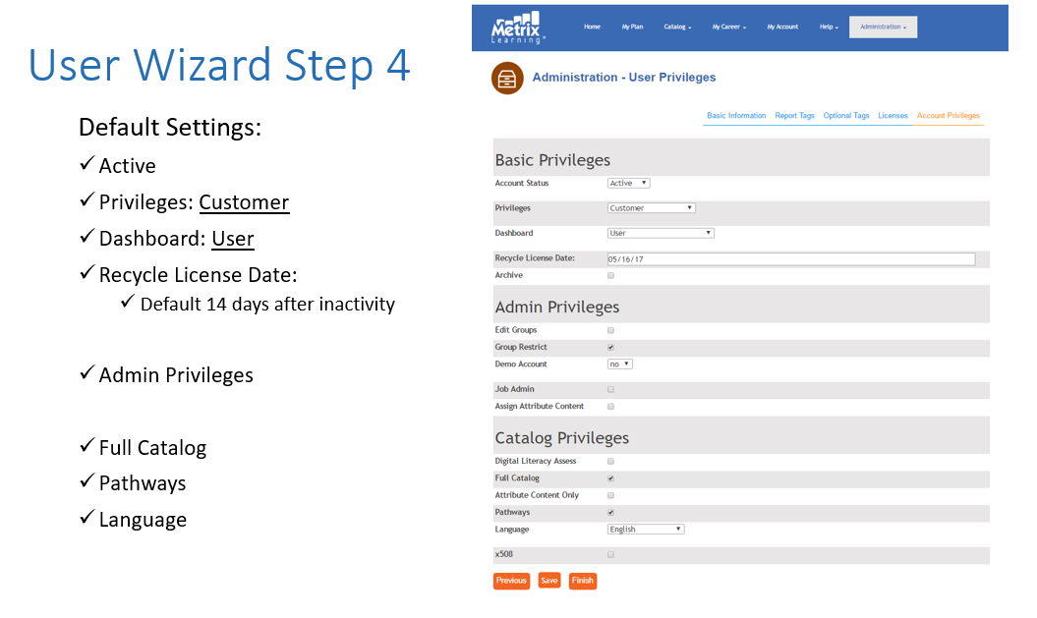

- Batch Upload

If an administrator needs to create 15+ user accounts at once (classroom, cohort program, large orientation group, etc.), they may contact the Metrix support team to have the accounts batch created.

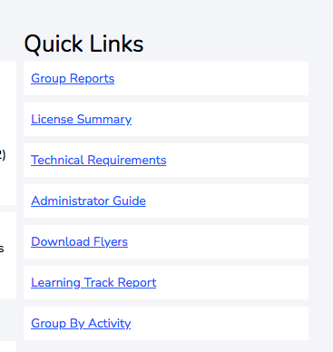
Reports

Case Management Report

The case management report is located on the administrator dashboard and allows you to customize reporting based on various attributes.
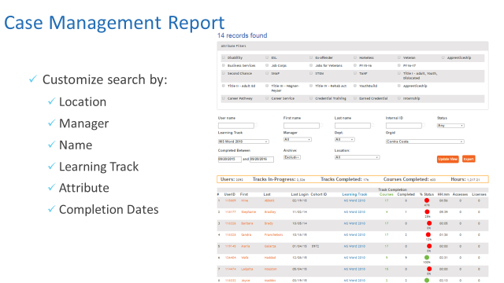

Administrator/ monthly Report

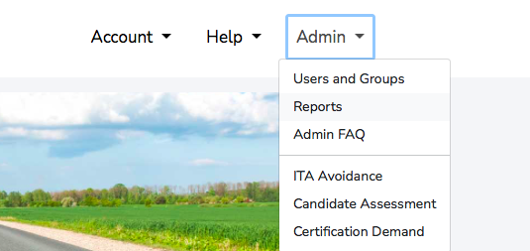
Review your organization’s monthly stats on users and activity:
- Go to the “Administration” Menu> click “Reports”

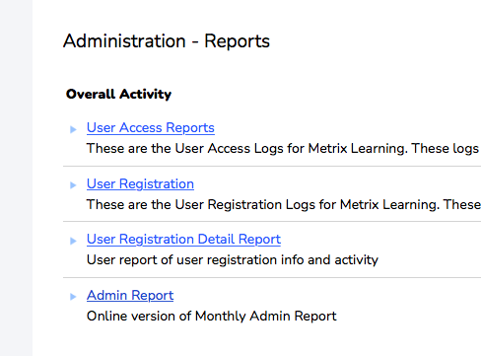
- Select Admin Report:

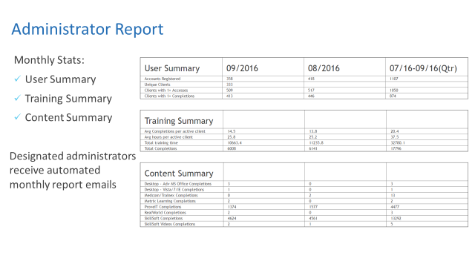

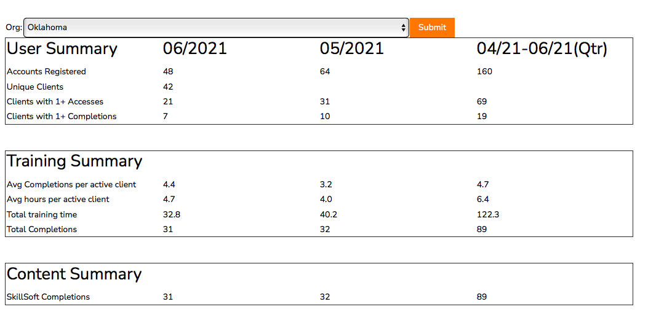

User Registration Report
From the reports page, choose User Registration Detail Report

After choosing the Start and End dates, click “Update” to view all of the information. The most recent name that populates was most recently added. You can also click the small Excel icon to export the information to Excel.

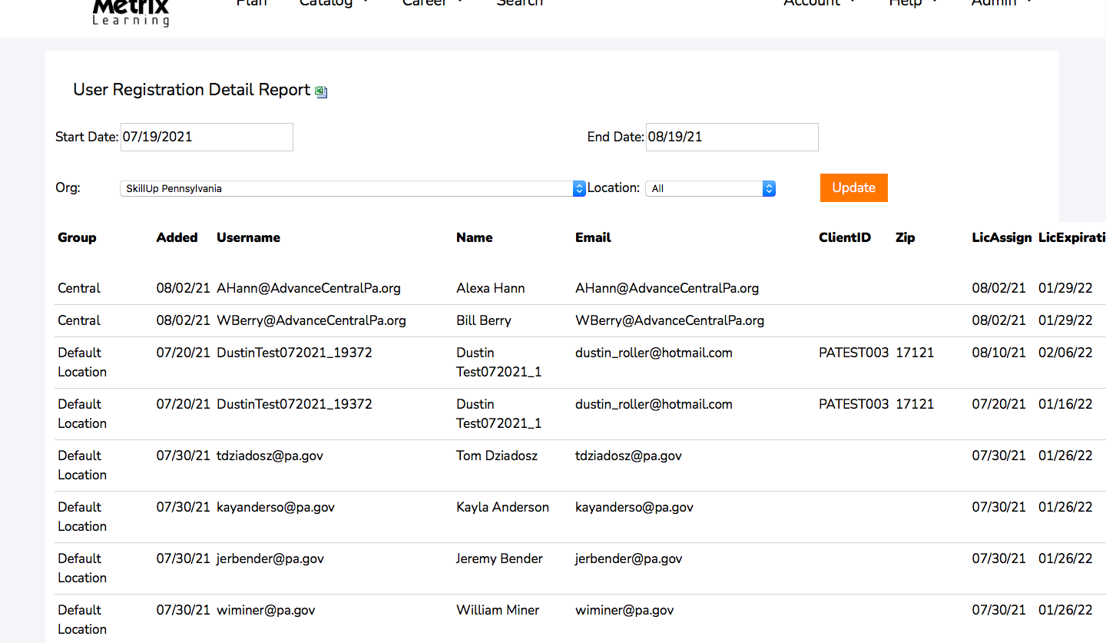

Group/Department Report
After clicking the Group/Department report, you will be prompted to choose “By User” or “By Activity”.
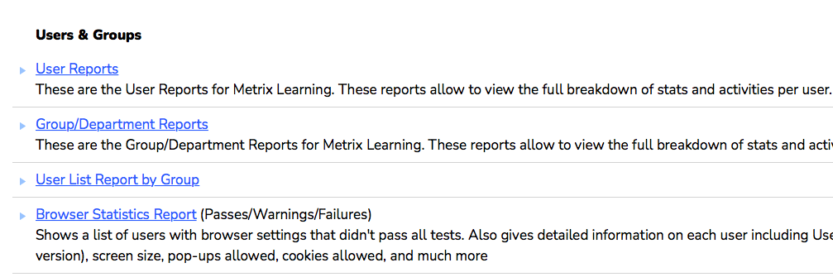

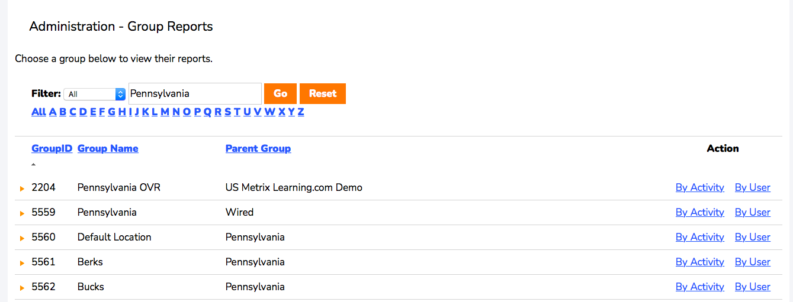

To view information on the entire state of Pennsylvania, please choose By Activity/By User from the Pennsylvania – Wired (Parent Group) option. If you’re looking for a specific Workforce Board, choose that workforce board (for example, Berks).
After clicking By Activity, you’ll see a full breakdown of the activity in that specific location. 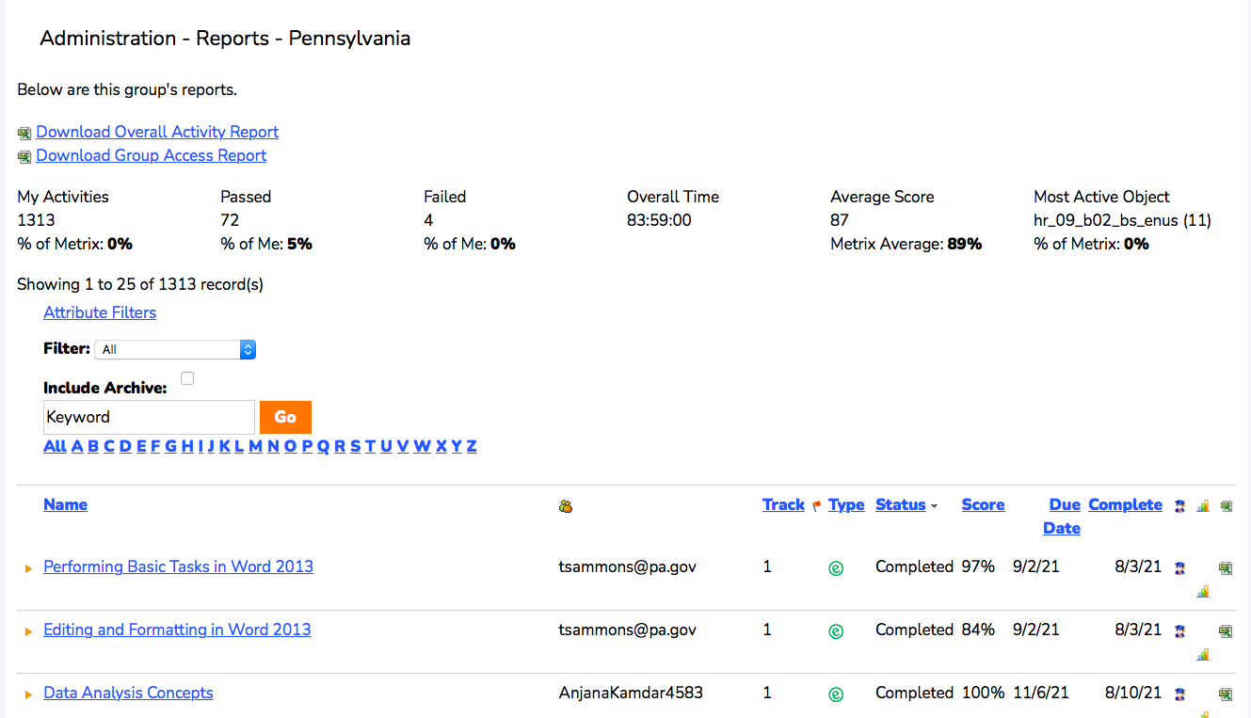
This includes overall time in the system, average score, and the most popular course. You can export this report by clicking the two download links at the top of the report.

Clicking By User will provide you a user summary based on the group chosen.
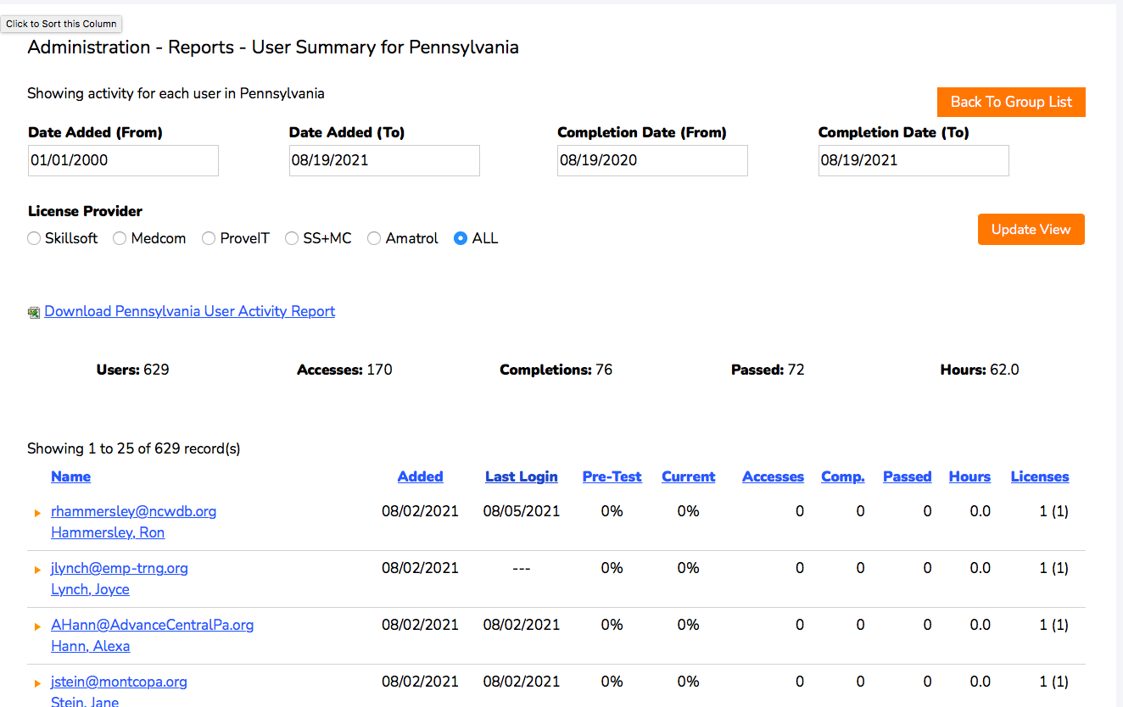
This shows the number of users added into the system, their course accesses, completions, passed, and their hours. You can also utilize the date filters to filter for specific dates.

Common Support

Edit User Functions:

To manage a customer’s account info, licenses, or coursework, go to Edit Users:

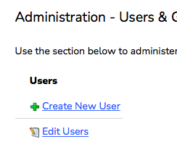
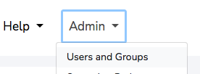
OR

+
Search for your customer by last name, username, or email address> Go:
Once located, select “edit” beneath Actions column:

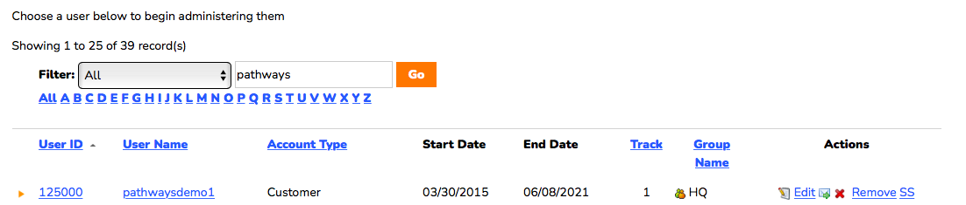

From this page, you can:
- Edit/Update account info (address, email, location)
- View learning plan and assign courses
- Manage licenses
- View User’s Activity Report
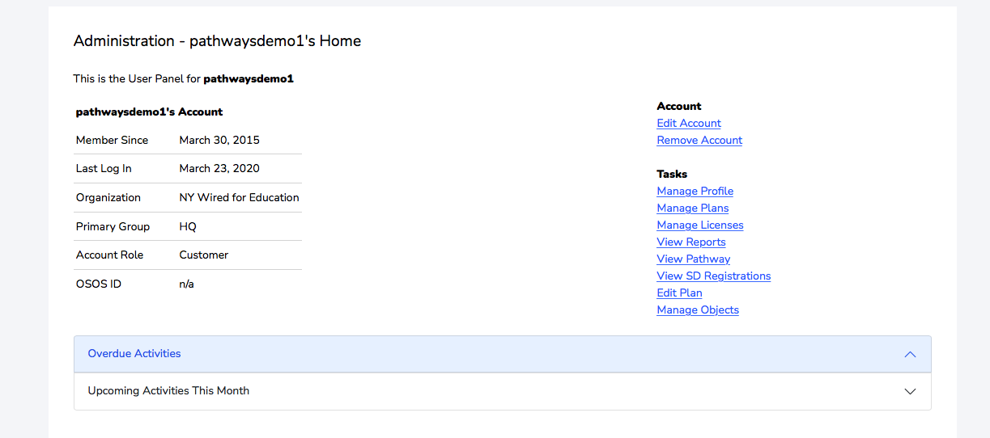
2.
4.
3.
1.

Three Apps:
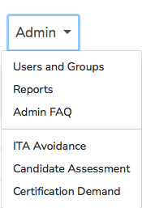
To access the three apps we offer to administrators, click on Administration to view them.

Our three apps are: ITA cost avoidance, Candidate Assessment, and our Certification Demand tool.

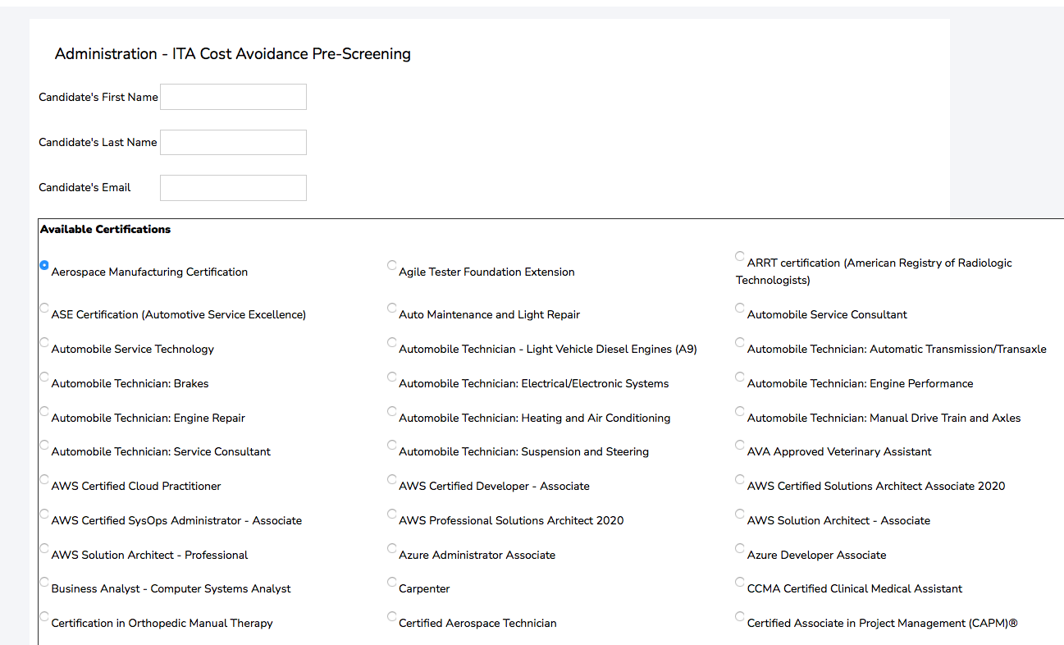
Clicking on our ITA Cost Avoidance/ITA Avoidance will redirect you to the page below. Fill out the customers information, choose the certification they’re interested in, then click submit at the bottom. An email with test instructions will be sent to the user. Using this tool can help see where a customer’s skills are in relation to the specific skill area required for a certification track. If they score low on this pre-screening test, they may not be prepared yet for the program, and may need to take some courses in the Metrix Learning system.

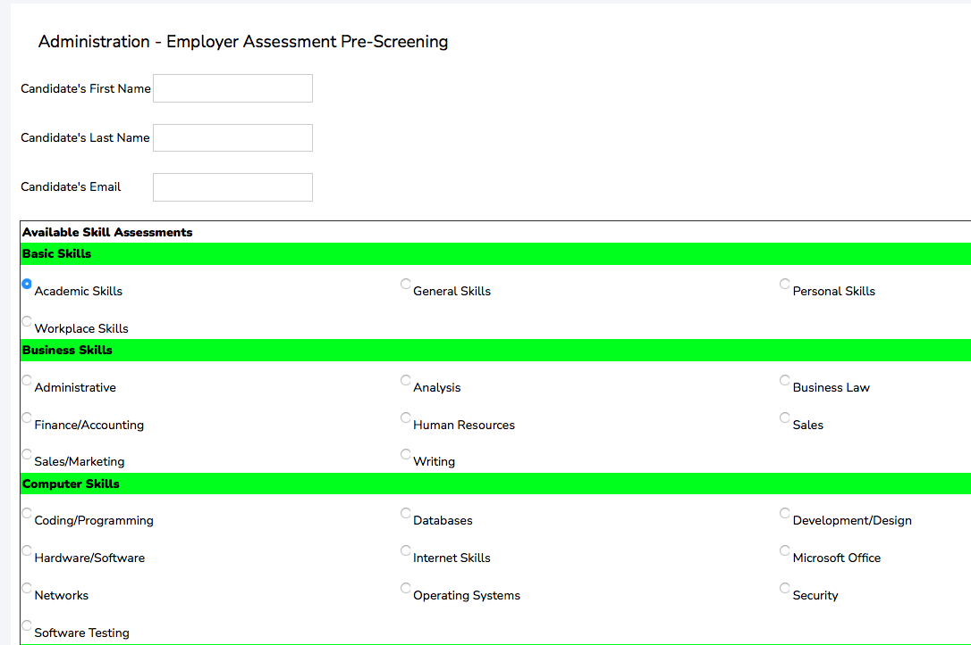
Clicking on Candidate Assessment will be a similar process for Employers.

After filling out the relevant data, a user will receive an email with instructions on how to access their pre-screening for a specific skill area. If the user scores lower than expected, they can take remediation courses in the system to close those skill gaps, and hopefully get a higher score on their next attempt.

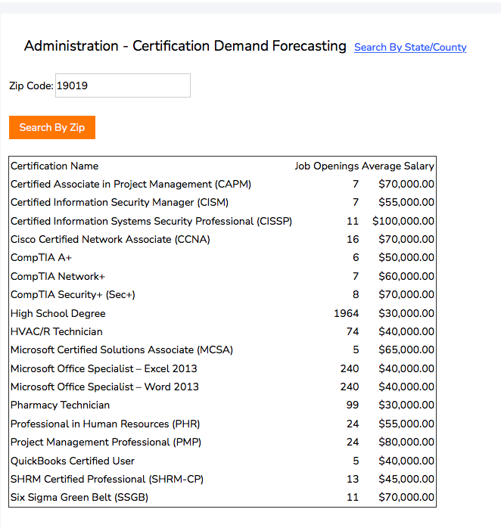
Clicking on Certification Demand provides you with a detailed list of certifications currently in demand based on a specific location, the number of job openings, and their average salary. You can either search by Zip Code:

Or by County:
