From the reports tab, choose:
- Fund Name = Prosperity 10K
- Year = select all, or current program year
- Provider Name = Select all
- Click “View Report” button

You are now ready to pull a variety of reports for P10k.

Data to check: Other Funding Source left blank
Report to Pull: Customer Flow Report

Click on the Customer Flow report. Once displayed, click on the total number enrolled. This brings up the list of all enrolled participants. Click on the disc icon to download the report to an Excel document.
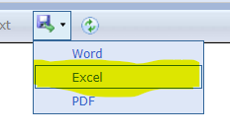
In Excel, select a cell in the header row, then go to Data and click Filter.
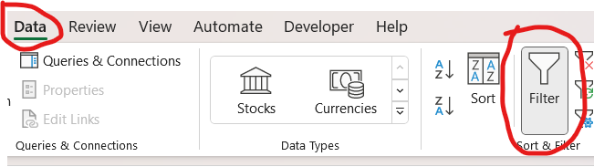

Then:
- Find the column header “Provider Name” and click the dropdown arrow to display the filter.
- Uncheck “Select All” and check your provider name.
- Find the column header “Other Funding Source” and click the dropdown arrow to display the filter.
- Uncheck “Select All” then scroll down to “(blanks)” and check it.
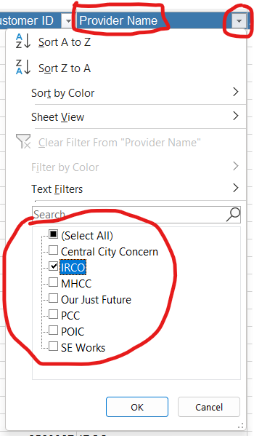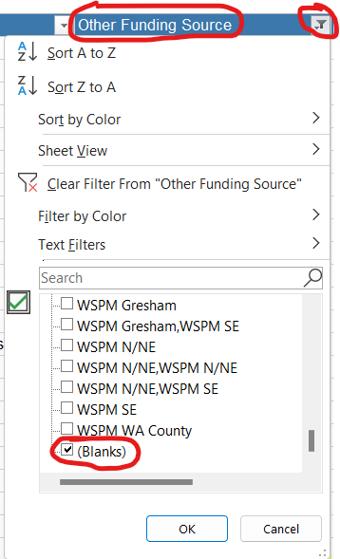

You now have a list of all your enrollments that do not have a program tagged in the Other Funding Source field.

Data to check: Auto Exits
Report to pull: Local Measures Report

Click on the Local Measures report. After the report is displayed, make selections in the header as needed. You can narrow the report by specific provider, or use the filter to select a specific “Other Funding Source.” At the very least, use the filter to set the Exit Status as "Auto Exit.”
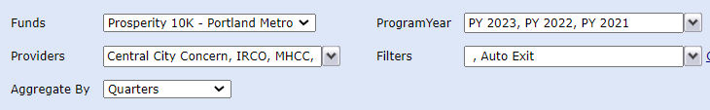

Once you’ve made your selections, click the View Report Button to update the report. Once displayed, find the Percent of Customers Successfully Exited line and click on the Grand Total percentage. This will produce a report of all your program participants who have auto exited and if they are counted as successful or not.
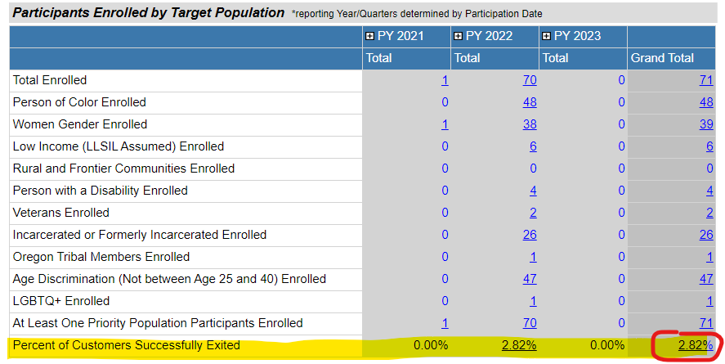

In the displayed list of participants, find the Numerator column. All participants with an “N” in this column need to be checked for a successful outcome recorded in the P10k record (training completion and/or employment with confirmation). If there is no successful outcome, edit the Auto Exit in the Outcomes Tab to “Exit – Not Successful.”

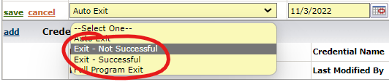

If the participant has a successful outcome recorded, add an “Exit – Successful” exit to the Program Status Control on the Outcomes Tab.

