EOP Portland Quarterly Reporting Guidance PY 23

Reporting Element | Definition and Methodology | How to Pull the Data

Enrollment
Enrollment Capacity= Intensive phase participants + actively engaged (receiving follow up services in the last 3 months) Retention and Advancement phase participants | Intensive phase participants | I-Trac Dashboard Reports (all the way down below standard reports)  - Choose Current Program Year  - Filters- NONE  - Current Program Status  - Use the number of Enrolled
 | Actively engaged Retention and Advancement phase participants | I-Trac Standard Reports: Services by Start Date  - Choose Current Program Year  - Filters- NONE  - Select the total of follow- up services for the current quarter  - Use # of Customers above the customer list

Success Measures
Attainment of Unsubsidized Employment | Denominator: All exited participants that were not employed at registration.  Numerator: The participants employed by the end of Q4 following the exit date. | I-Trac Standard Reports: Local Measures  - Choose Current Program Year  - Filters- NONE  - Report Total
Attainment of Career Track Employment | Denominator: All exited participants.  Numerator: The participants that are employed by the end of Q4 following the exit date in a position that aligns with the Career Track Employment goal identified in their Career Plan. | I-Trac Standard Reports: Local Measures  - Choose Current Program Year  - Filters- NONE  - Report Total
Employment Rate in Q2 following the Exit to Follow-Up Date | Denominator: All exited participants enrolled.  Numerator: Number employed in Q2 after Exit to Follow-Up | I-Trac Standard Reports: WIOA Performance  - Choose Current Program Year  - Filters= NONE  - Report Total
Employment Rate in Q4 following the Exit to Follow-Up Date | Denominator: All exited participants enrolled.  Numerator: Number employed in Q4 after Exit to Follow-Up | I-Trac Standard Reports: WIOA Performance  - Choose Current Program Year  - Filters= NONE  - Report Total
Advancement in employment as demonstrated by gain in earnings, wage or benefits. | Denominator: All participants that were employed at enrollment or who are in the Unsubsidized or Career Track Employment numerator.  Numerator: The participants that have at least one advancement (defined below) in employment by the end of Q4 following the exit date.  Advancement Definition: An increase in wage, hours worked, or availability of benefits. The base from which advancement is calculated is the employment elements at enrollment or employment elements with the job secured during program engagement. The benefit start date is not considered an advancement if a position is offered and accepted that includes a benefit package, but the benefits do not become effective immediately (i.e., probationary period completed, 30-day grace period, etc.). | I-Trac Standard Reports: Local Measures  - Choose Current Program Year  - Filters- NONE  - Report Total
Training Starts | # of participants who started training this quarter | I-Trac Standard Reports: Global  - Choose Current Program Year  - Filters- NONE  - Report Total YTD
Training Completions | # of participants who completed training this quarter | I-Trac Standard Reports: Global  - Choose Current Program Year  - Filters- NONE  - Report Total YTD
Number of Exits (into Follow up) |  | I-Trac Standard Reports: Customer Flow  - Choose Current Program Year  - Filters- NONE  - Report Total YTD for Exit line
Number of Full Program Exits |  | I-Trac Standard Reports: Customer Flow  - Choose Current Program Year  - Filters- NONE  - Report Total YTD for Full Program Exit line
Participant Demographic Plan
Participants served who are people of color | Denominator: Enrolled+ Carry-in Enrolled+ Follow up+ carry-in Follow up  Numerator: Enrolled+ Carry-in Enrolled+ Follow up+ carry-in Follow up (with people of Color filter applied) | I-Trac Standard Reports: Customer Flow  - Choose Current Program Year  - Filters- People of Color

I-Trac Reports

Enrolment Capacity
Part 1:
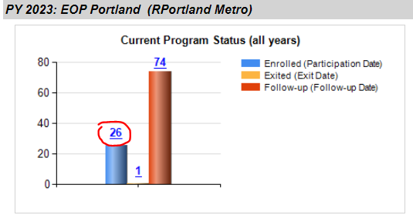
Add part Two:
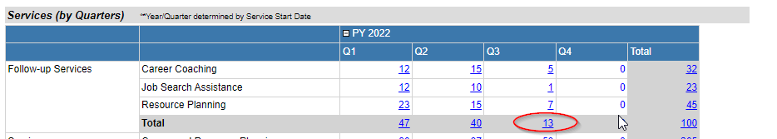
Your Org Name Here
Capacity=26+8=34

Success Measures

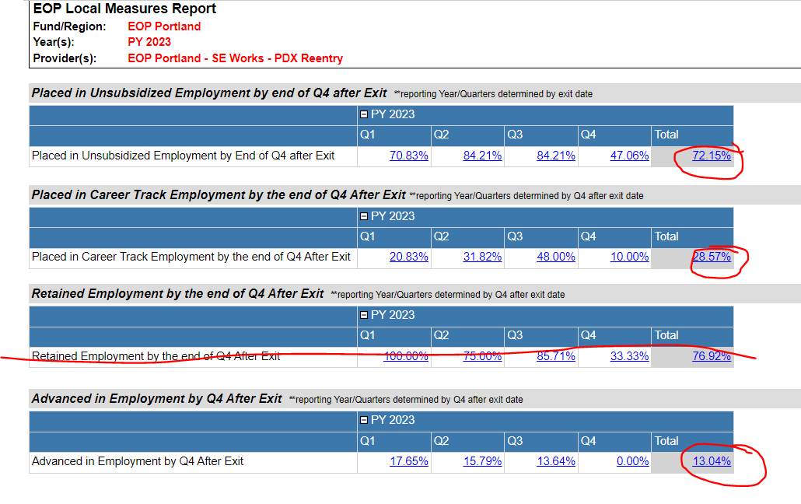
Your org name here

Employment Rate in Quarter 2/4 following the exit into Follow- Up
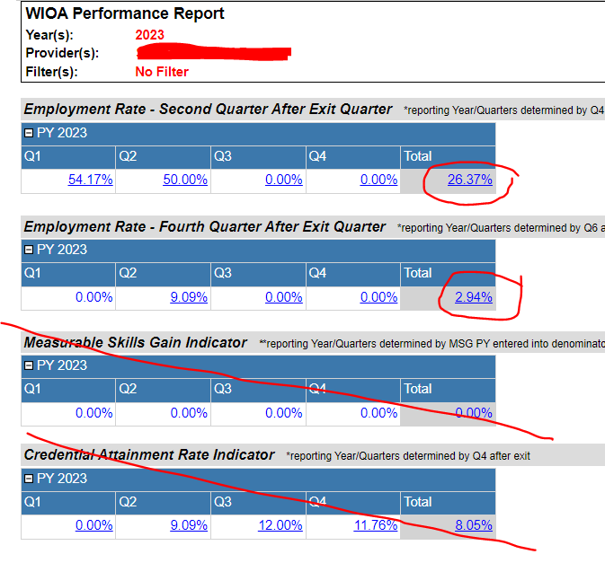
Training Starts and Completions
Your org name here
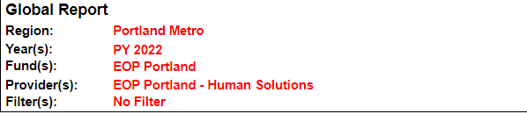
Your org here
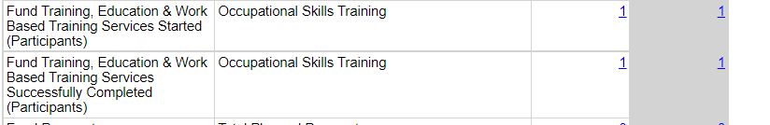

People of Color served during Quarter
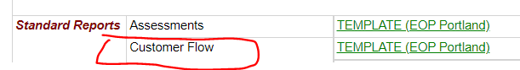
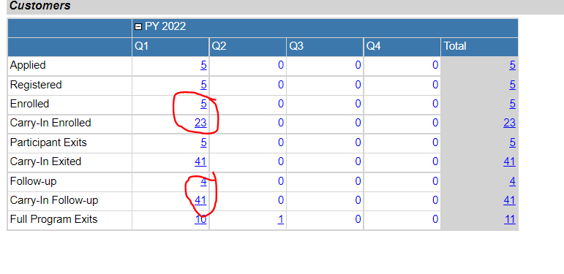
Denominator: 5+23+4+41= 73
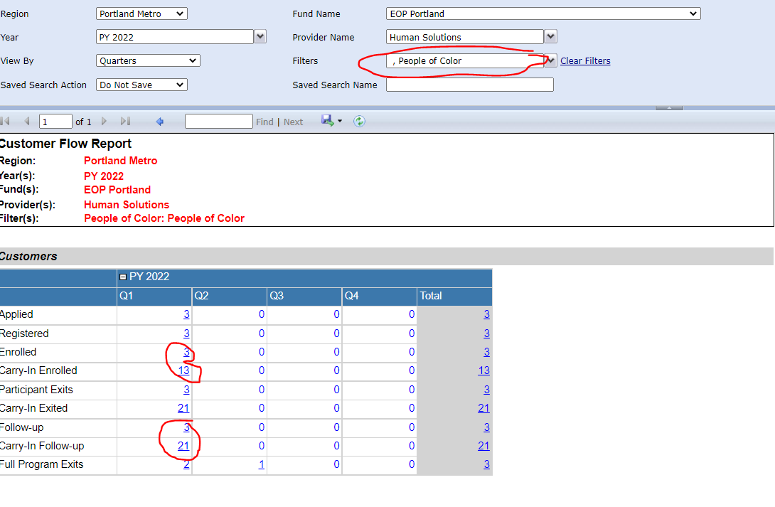
Numerator: 3+13+3+21=40
% of People of Color served 40/73=.54 54%
Number of Exits and Full Program Exits
