RA Hub Quarterly Reporting Guidance PY 23
I-trac
Reporting Element | Definition and Methodology | How to Pull the Data

Referrals received
Number of referrals received | All referrals submitted to the HUB via i-trac | I-Trac Standard Reports: Customer Flow  - Choose Current Program Year  - Filters- NONE  - Report the number on “Applied” line for the Reporting quarter and Total
Number of referrals accepted | All referrals that were accepted by the RA Hub | I-Trac Standard Reports: Customer Flow  - Choose Current Program Year  - Filters- NONE  - Report the number on “Registered” line for the Reporting quarter and Total

Success Measures
Number of EOP participants provided with housing placement (Rapid Rehousing) | Number of Rapid Rehousing participants who received at least one housing related payment | I-Trac Standard Reports: Rent Assistance Payments  - Choose Current Program Year  - Filters- NONE  - Go to Rent Assistance Payments section  - Select Rapid Rehousing Total  - Open list report, find # of customers  - Report # of customers for the Reporting Quarter and Total
Number of EOP participants provided with housing placement (Rapid Rehousing) who are People of Color | Number of Rapid Rehousing participants who received at least one housing related payment and are people of color | I-Trac Standard Reports: Rent Assistance Payments  - Choose Current Program Year  - Filter- People of Color  - Go to Rent Assistance Payments section  - Select Rapid Rehousing Total  - Open list report, find # of customers  - Report # of customers for the Reporting Quarter and Total
Number of EOP participants provided with eviction prevention (Homeless Prevention) | Number of Homeless Prevention participants who received at least one housing related payment | I-Trac Standard Reports: Rent Assistance Payments  - Choose Current Program Year  - Filters- NONE  - Go to Rent Assistance Payments section  - Select Homeless Prevention Total  - Open list report, find # of customers  - Report # of customers for the Reporting Quarter and Total
Number of EOP participants provided with eviction prevention (Homeless Prevention) | Number of Homeless Prevention participants who received at least one housing related payment who are people of color | I-Trac Standard Reports: Rent Assistance Payments  - Choose Current Program Year  - Filters- People of Color  - Go to Rent Assistance Payments section  - Select Homeless Prevention Total  - Open list report, find # of customers  - Report # of customers for the Reporting Quarter and Total
Total unduplicated number of participants provided with housing placement & eviction prevention | Number of Homeless Prevention and Rapid Rehousing participants who received at least one housing related payment | I-Trac Standard Reports: Rent Assistance Payments  - Choose Current Program Year  - Filters- none  - Go to Rent Assistance Payments section  - Select Grand Total line  - Open list report, find # of customers  - Report # of customers for the Reporting Quarter and Total
Total unduplicated number of participants provided with housing placement & eviction prevention who are People of Color | Number of Homeless Prevention and Rapid Rehousing participants who received at least one housing related payment who are People of Color | I-Trac Standard Reports: Rent Assistance Payments  - Choose Current Program Year  - Filters- People of Color  - Go to Rent Assistance Payments section  - Select Grand Total line  - Open list report, find # of customers  - Report # of customers for the Reporting Quarter and Total
Housing Retention for 6 months after rent assistance ends | Numerator: Participants who are housed 6 months after exit  Denominator: All participants served who were exited 6 months prior | I-Trac Standard Reports: Local Measures  - Choose Current Program Year  - Filters- NONE  - Go to Retained in Housing 6 months after Exit section  - Report Total % for the reporting quarter and Total column  - Open list report by clicking on the percentage  - Report Numerator and Denominator on the report
Housing Retention for 6 months after rent assistance ends for People of Color | Numerator: Participants who are housed 6 months after exit who are people of color  Denominator: All participants served who were exited 6 months prior who are people of Color | I-Trac Standard Reports: Local Measures  - Choose Current Program Year  - Filters- People of Color  - Go to Retained in Housing 6 months after Exit section  - Report Total % for the reporting quarter and Total column  - Open list report by clicking on the percentage  - Report Numerator and Denominator on the report
Housing Retention for 12 months after rent assistance ends | Numerator: Participants who are housed 12 months after exit  Denominator: All participants served who were exited 12 months prior | I-Trac Standard Reports: Local Measures  - Choose Current Program Year  - Filters- NONE  - Go to Retained in Housing 12 months after Exit section  - Report Total % for the reporting quarter and Total column  - Open list report by clicking on the percentage  - Report Numerator and Denominator on the report
Housing Retention for 12 months after rent assistance ends for People of Color | Numerator: Participants who are housed 12 months after exit who are people of color  Denominator: All participants served who were exited 12 months prior who are people of Color | I-Trac Standard Reports: Local Measures  - Choose Current Program Year  - Filters- People of Color  - Go to Retained in Housing 12 months after Exit section  - Report Total % for the reporting quarter and Total column  - Open list report by clicking on the percentage  - Report Numerator and Denominator on the report

I-Trac Reports- Visuals
Number of Referrals Received
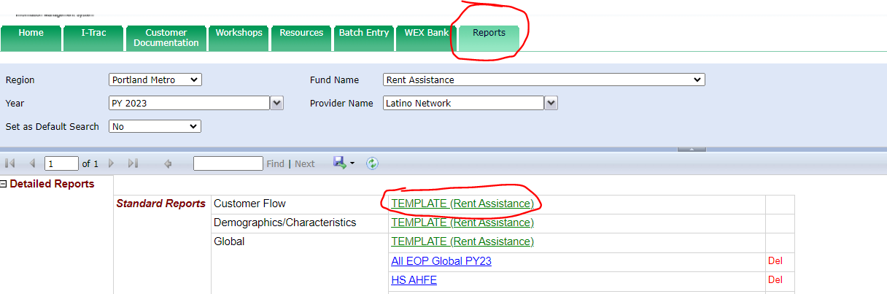
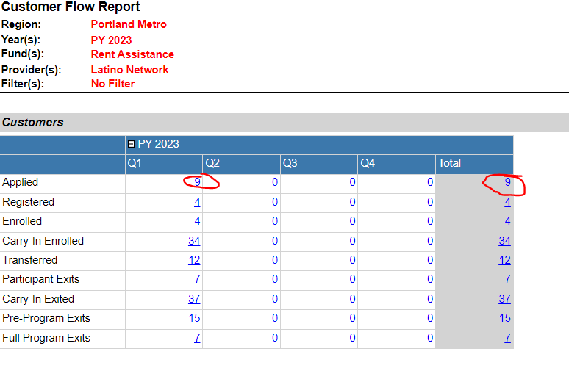
Number of referrals accepted
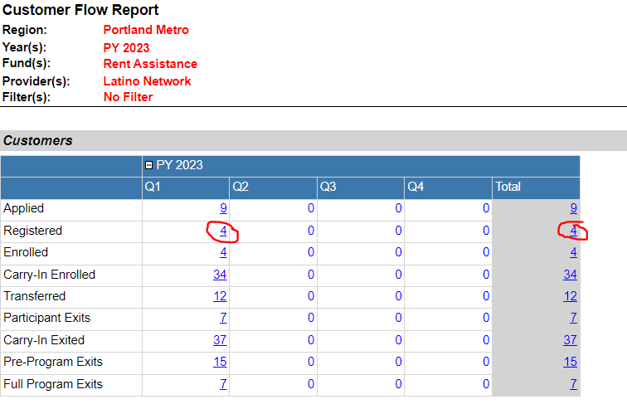
Number of participants provided with housing placement/prevention
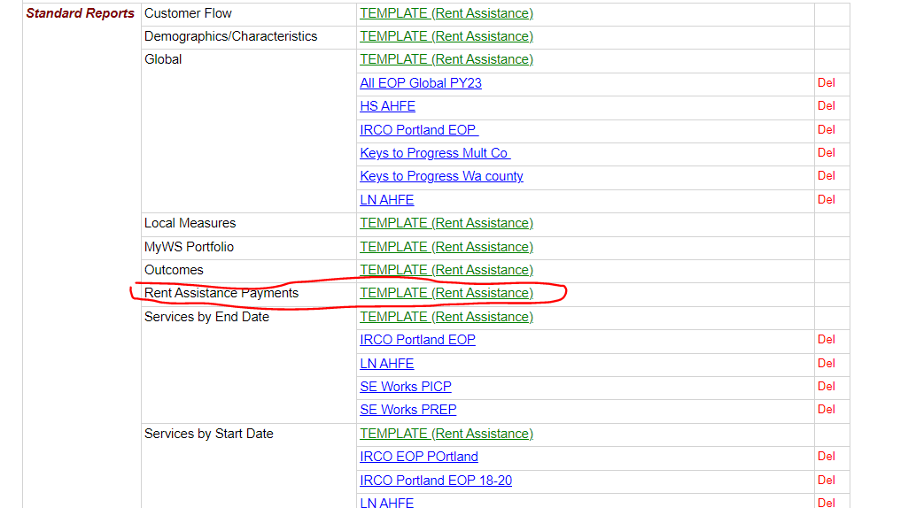
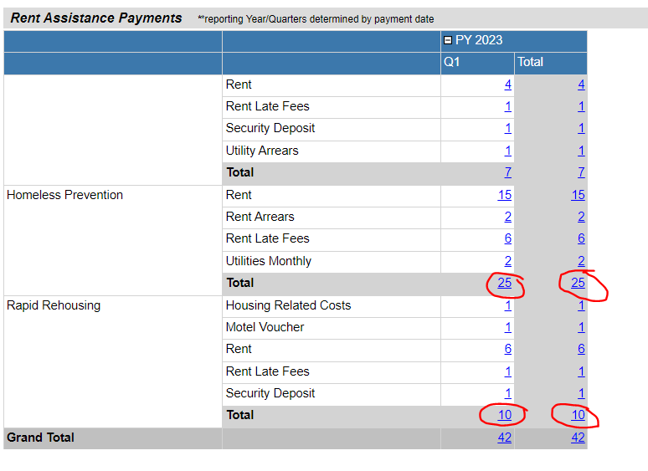
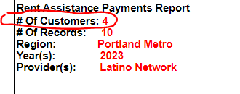
Number of participants provided with housing placement/prevention who are people of color

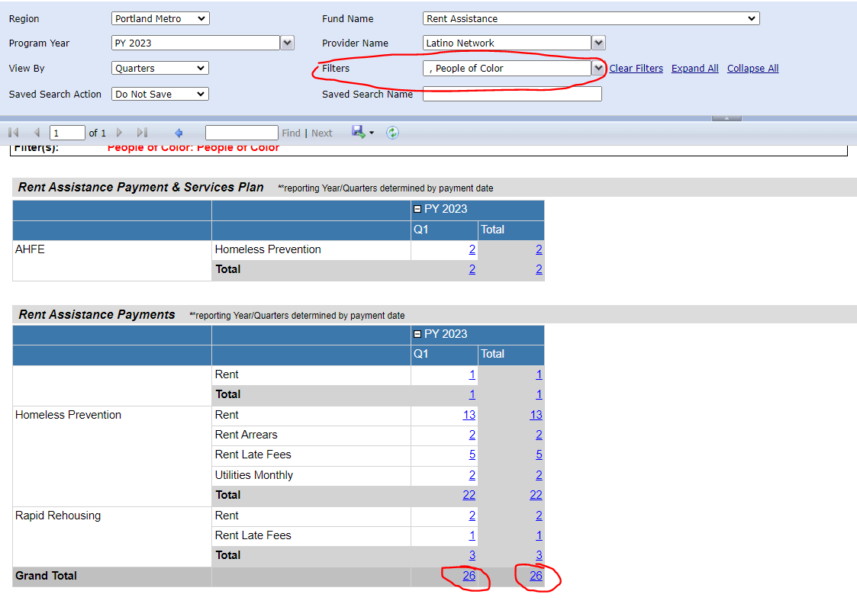

Retained Housing 6 month/12 month after Exit
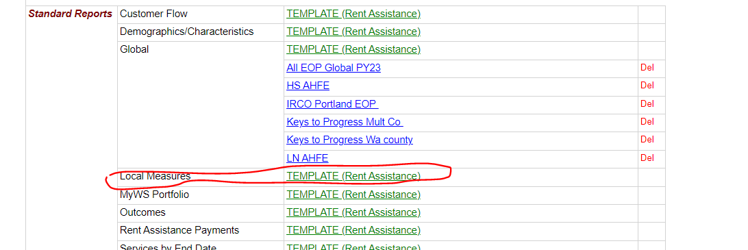

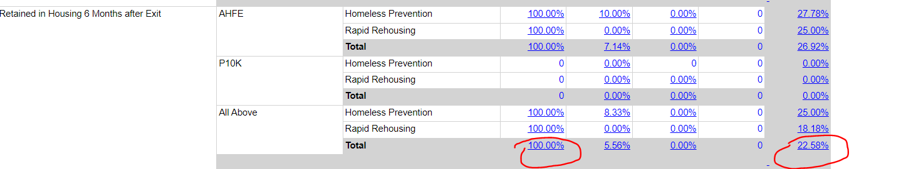
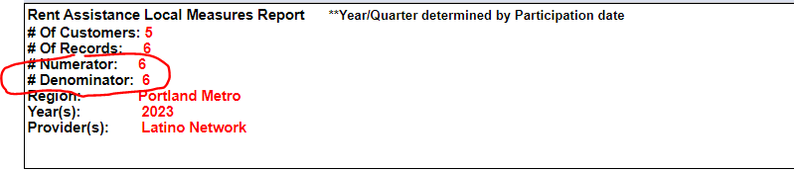

Service Point Report guidance can be found here. Use Program Performance and Follow ups/Housing Retention reports.

