Table of Contents

CAREER COACH DATA ENTRY 2
Create I-Trac Rent Assistance Record 3
Registration Tab for Coaches 4
Get Rent Assistance Application Signed 5
Referral Acceptance or Rejection 5
Services Tab for Coaches 6
Payments Tab for Coaches 7
Outcomes Tab for Coaches 7
Case Notes Tab for Coaches 7
RENT ASSISTANCE HUB STAFF DATA ENTRY 8
Providers Tab for Hub Staff 8
Registration Tab for Hub Staff 8
Services Tab for Hub Staff 10
Payments Tab for Hub Staff 11
Outcomes Tab for Hub Staff 12
Case Notes Tab for Hub Staff 14

CAREER COACH DATA ENTRY

BEFORE adding a rent assistance referral to I-Trac, coaches must complete the following with the participant:

- A Career Plan - updated within the last 3 months and uploaded to the participant’s I-Trac’s Customer Documentation record as an “Individual Plan”.
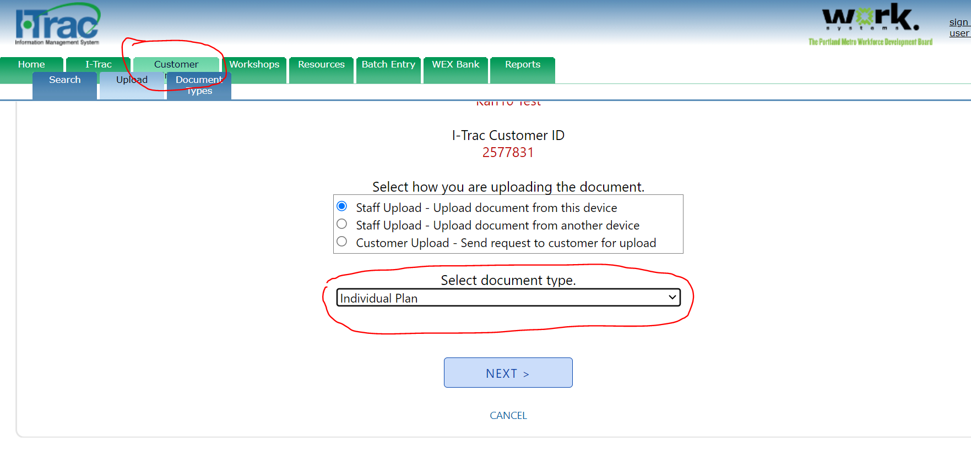
- A Prosperity Budget - saved within the last 3 months.
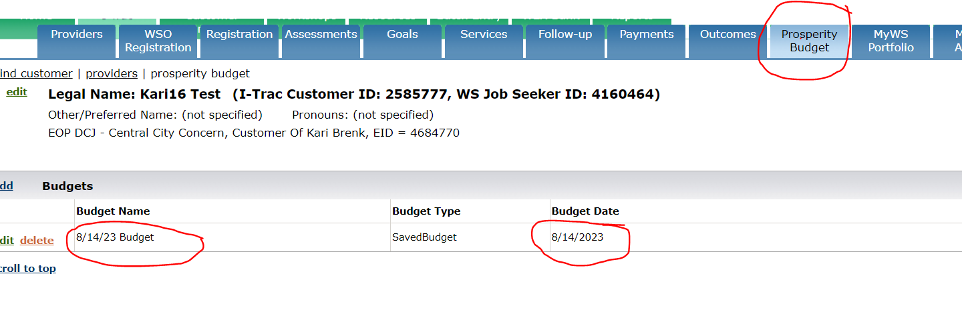

Create I-Trac Rent Assistance Record

- Find the participant in I-Trac. Using Find Customer, search for the participant record by Name, I-Trac Customer ID and click Select. Confirm Birth MM/DD and Last 4 SSN (if available) that show to verify that you are selecting the correct participant in I-Trac.
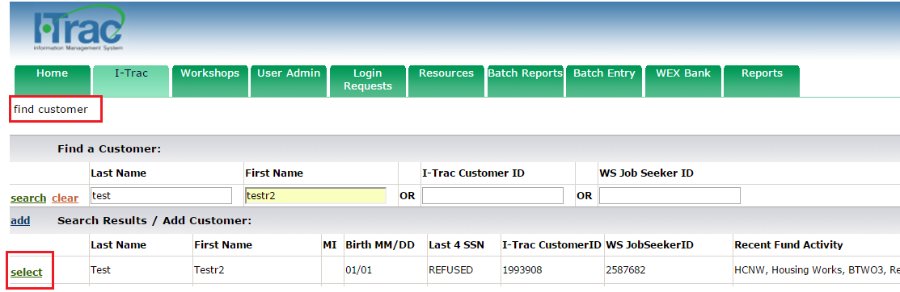

- On the Providers Tab, click add in the Providers Control to add the Rent Assistance enrollment record.
- Service Provider = Rent Assistance- Choose the hub provider you are referring the participant to for rent assistance.
- Customer Of = Choose Your Name. Keep the Customer Of name as the career coach making the referral, do not change to be a specific Rent Assistance Hub staff.
- Application Date = The date the customer is completing the registration process (NOTE: This date must be before the date of the first Rent Assistance grant funded service).

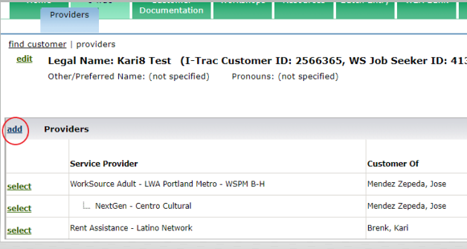

- Complete Registration Tab data entry. All required data (yellow fields) on the Registration Tab must be entered to complete Registration.

Registration Tab for Coaches

Career coaches create the I-Trac Rent Assistance record and complete the Registration Tab.
To assist with data entry, some Registration information for the following controls on the Registration Tab may automatically import from the most recent active enrollment in I-Trac. Please review and update this information to reflect what is true at the time of enrollment in the Rent Assistance fund.
Address
Phones
Email Address
Ethnicity
Race
Other Demographics
Employment Characteristics- To be eligible must be Homeless or Housing Insecure
Employment Status
Public Assistance

The following controls do not automatically import and must be completed.
Other Funding Source (formerly Co-enrollment)- choose from the dropdown other programs the participant is actively enrolled in. This is a required field.
Six Month Income- complete for current income. This is a required field.
Other Rent Assistance Information
- Adults in Household -Numerical field. This is a required field.
- Children in Household- Numerical field. This is a required field.
- Total Amount Requested- Enter the total requested dollar amount. This is a required field.
- Housing Type at Registration – Choose Rapid Rehousing or Homeless Prevention as defined in the Rent Assistance Regional Program Standards. This is a required field.
Service Definitions from Rent Assistance Regional Program Standards
Rapid Rehousing services quickly connect households experiencing homelessness to permanent housing. Rapid Rehousing services are provided to individuals that are currently experiencing homelessness or fleeing domestic violence.
Homelessness Prevention services help prevent households at risk of becoming homeless from becoming homeless. Homelessness Prevention services serve individuals that currently have housing or live in an apartment, but who are facing eviction or who may be at risk of becoming homeless.

- Plan to pay rent at end of Rent Assistance - This is a required text field.
- Source of Income- This is a required text field.
- Past Property Debt - This is a required ‘yes or no’ field. Provide details if yes.
- Credit Debt- This is a required ‘yes or no’ field. Provide details if yes.
- Eviction History- This is a required ‘yes or no’ field. Provide details if yes.
- Criminal History- This is a required ‘yes or no’ field. Provide details if yes.
Registration Notes: Add any general information about the participant’s ’s current situation and rent assistance needs that Rent Assistance staff should know. Details help them serve the participant more efficiently.

Registration Results Control will tell you what information is missing or any ineligible reasons. If no Ineligible Reasons are listed, the Career Coach completes the Registration Completion Control for Registered By.

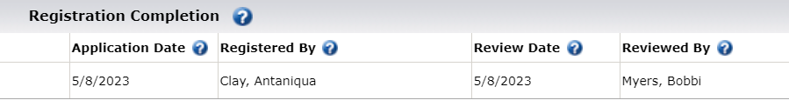

The Reviewed By is completed by the Rent Assistance Hub staff. To complete the Review and enter a Review Date the Rent Assistance Hub staff must first confirm that a Career Plan and Prosperity Budget have been uploaded to I-Trac and Rent Assistance Application is signed by the participant.

Get Rent Assistance Application Signed

Once registration is completed, go to the Customer Documents Menu to get the application signed. Either 1) send an electronic signature request to the participant, or 2) print and have the participant sign the application and then upload the signed application to the participant’s I-Trac Customer Documentation record.

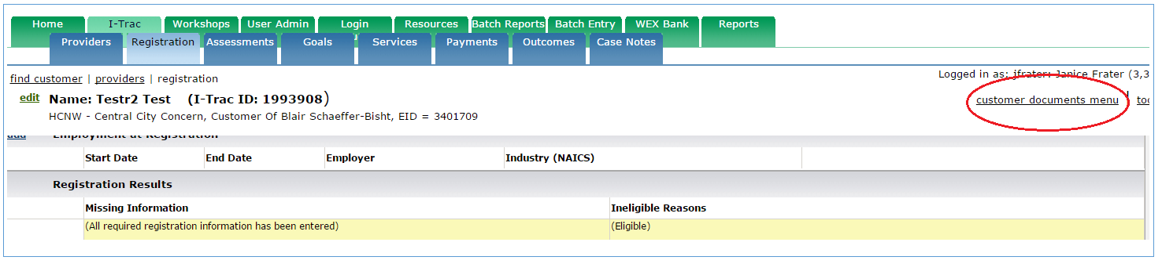

Referral Acceptance or Rejection

Once these steps have been completed by the Career Coach, the coach emails the Hub staff with the I-Trac ID to inform them a referral has been made.

The Rent Assistance Hub staff reviews the data on the Registration Tab, and then confirms 1) a career plan is uploaded to I-Trac, 2) a Prosperity Planner budget is completed in I-Trac, and 3) an application has been signed. The Rent Assistance Hub staff enters a Review Date and Reviewed By to show acceptance of the referral on the Registration Tab. The first service of Rapid Rehousing or Homelessness Prevention entered by the Hub staff on the Services Tab sets the Participation Date.

If a referral is not accepted by the Hub, the Hub staff enters a Pre-Program Exit status on the Outcomes Tab, adds a case note explaining the reason, and informs the Career Coach.

The Hub staff can’t begin issuing rent assistance until a Career Coaching service from the participant’s EOP program record has been copied to the rent assistance record. The participant is then fully enrolled in the Rent Assistance record.

Services Tab for Career Coaches

Current Housing Status Control

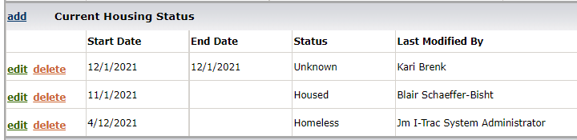

The Current Housing Status Control is for case management purposes and can be entered by Career Coaches or Hub staff. It is NOT used for performance reporting. This control is only to inform others about the current housing status of the participant. We recommend reviewing this status when entering monthly services and updating it when housing status changes. This is different than Housing Status at Exit Control on the Outcomes Tab.

Services Control

To be referred to and receive rent assistance, participants must be engaged with their Career Coach in each month that the participant is receiving rent assistance as defined in the Rent Assistance Regional Program Standards.

Career Coaches must verify program engagement by copying services from the EOP program record into the Rent Assistance record. Career Coaches do not enter services directly on the Services Tab in Rent Assistance records.

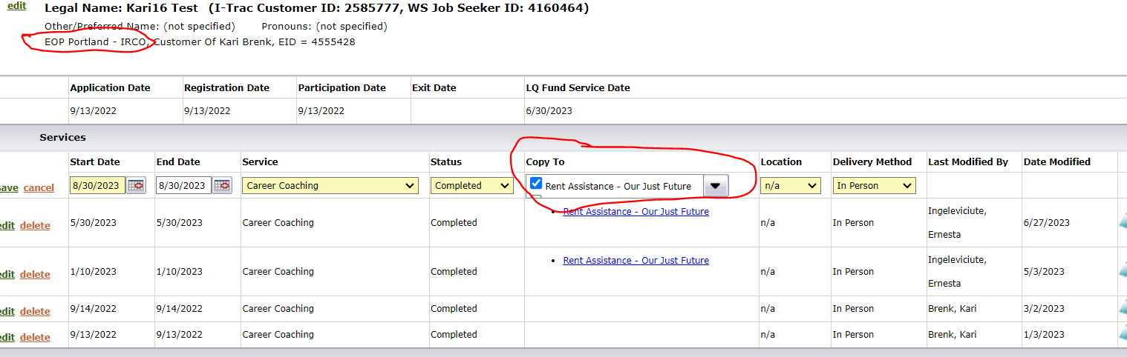

Service engagement must be entered each subsequent month that rent assistance is received until rent assistance ends. The Hub must verify monthly services by the career coaching provider before paying the rent. Engagement is verified for the previous month, and rent is paid in the current month for the next month. The Hub cannot pay rent for participants who are not engaged with services.

Here are the types of career coaching services that EOP coaches can enter into the EOP program record and then copy into the Rent Assistance record:
- Career and Resource Planning
- Career Coaching
- Career Mapping Workshop
- Job Search Assistance

See the Rent Assistance Regional Program Standards for definitions of these services. These services update the Last Qualifying (LQ) Fund Service Date; none of them sets the Participation Date.

Payments Tab for Career Coaches

Only the Rent Assistance Hub providers enter data on the Payments Tab.

Outcomes Tab for Career Coaches

Only the Rent Assistance Hub providers enter data on the Outcomes Tab.

Case Notes Tab for Career Coaches

Narrative case notes are not a service but they may be completed in I-Trac to document additional detail around participation activities; successes and challenges; progress towards goals; and performance outcomes. Narrative case notes entered should not repeat information already entered in the I-Trac system, but expand upon, provide context to or augment service or employment data. Detailed case notes may help speed up rent assistance services.

RENT ASSISTANCE HUB STAFF DATA ENTRY

Providers Tab for Hub Staff

Career Coaches create the I-Trac Rent Assistance record. To create the I-Trac record for Rent Assistance-Service Provider the Career Coach chooses the Hub provider that the participant is being referred to for rent assistance. The Career Coach keeps the Customer Of name as the Career Coach; career coaches do not change the name to be a specific Hub staff person.

The Rent Assistance Hub staff is then responsible for reviewing the referral in I-Trac and deciding what Hub staff is assigned to the participant. At that point, the Hub staff person should change the Customer Of to the name of the assigned Hub staff.

Registration Tab for Hub Staff

Career Coaches complete the Registration Tab. The Rent Assistance Hub staff person then reviews the data on the Registration Tab. As part of this review, the Hub staff person also confirms these three things are completed:

- a Career Plan, no older than 3 months, is uploaded to the I-Trac Customer Documentation Tab as “Individual Plan”

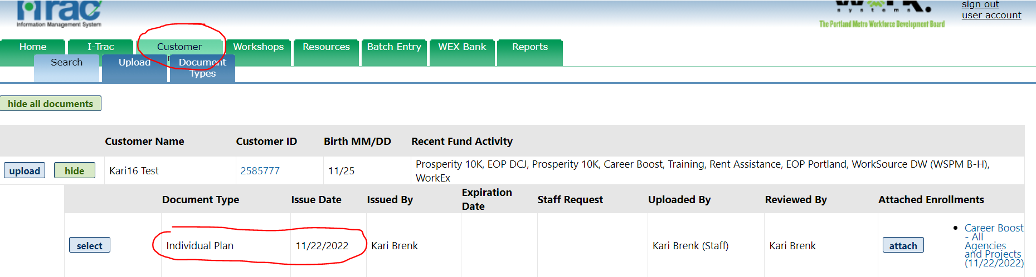

- a Prosperity Planner budget has been completed or updated within the last three months in the I-Trac Prosperity Budget Tab

- the participant has signed the Rent Assistance Application electronically or a signed application is uploaded in the participant’s I-Trac Customer Documentation record.

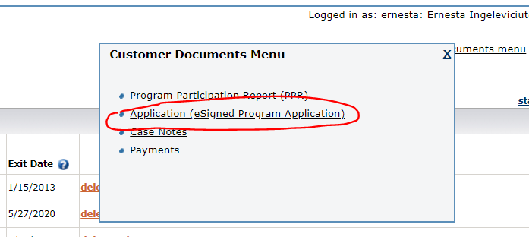

Or

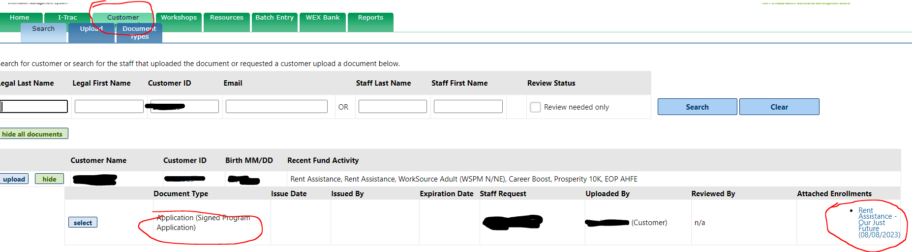

Once these three steps are completed the Hub staff enters a Review Date and Reviewed By to show acceptance of the referral. Hub staff have 45 days to accept the referral. The first service of Rapid Rehousing or Homelessness Prevention entered by the Hub on the Services Tab sets the Participation Date.

If a referral is not accepted by the Hub, the Hub staff enters a Pre-Program Exit status on the Outcomes Tab, adds a case note explaining the reason, and informs the Career Coach.

The Hub cannot begin issuing rent assistance until the Career Coach copies a coaching service from the participant’s program record to the Rent Assistance record. The participant is then fully enrolled in the Rent Assistance record.

Services Tab for Hub Staff

Current Housing Status Control

The Current Housing Status Control is for case management purposes and can be entered by areer coaches or Hub staff. It is NOT used for performance reporting. This control is only to inform others about the current housing status of the participant. We recommend reviewing this status when entering monthly services and updating it when housing status changes. This is different than Housing Status at Exit Control on the Outcomes Tab.

Services Control

To be referred to and receive rent assistance, participants must be engaged with their Career Coach in each month that the participant is receiving rent assistance as defined in the Rent Assistance Regional Program Standards.

Career Coaches must verify program engagement by copying services from the EOP program record to the Rent Assistance record. Service engagement must be entered each subsequent month that rent assistance is received until rent assistance ends. The Hub must verify monthly services by the career coaching provider before paying the rent. Engagement is verified for the previous month, and rent is paid in the current month for the next month. The Hub cannot pay rent for participants who are not engaged with services.

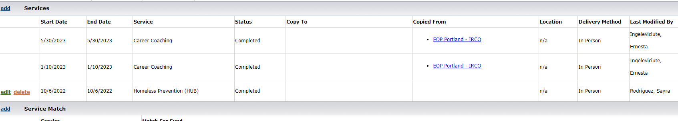

Hub staff can enter three types of services into the Rent Assistance record. See the Rent Assistance Regional Program Standards for definitions. Hub staff enter a service 1) when they accept a referral, 2) each time they meet with a participant, virtually or in person, and 3) when they exit the Rent Assistance Record.

HUB SERVICE TYPES | STARTS PARTICIPATION? | UPDATES LQ  FUND SERVICE DATE? | PROGRAM NOTES/RULES
Rapid Rehousing | yes | no | These two services represent the housing supports provided by the Hub. One of them is the first service entered by the Hub to set which housing type the participant is receiving.  After setting the Participation Date, these services do not extend the LQ service date to extend participation, but the Hub staff enters one of these services each time they meet with the participant.
Homeless Prevention | yes | no
Hub  Final Rent Exit | yes | yes | This service is the last service that is entered by Hub staff before exiting the Rent Assistance record. The date of this service will set the Exit date. The date of this service is the last day of the month for which the rent has been paid.

Payments Tab for Hub Staff

All payments made with Worksystems funds by the contracted Hub providers are tracked on the Payments Tab. Do not enter payments into I-Trac that are supported fully by customers’ eligibility for, and participation in, other local housing support programs outside of Worksystems’ infrastructure. When payments are entered into I-Trac, staff must complete all fields highlighted in yellow.

Service Point ID Control

After enrollment is complete, the Hub enters the Service Point ID on the Payments Tab.
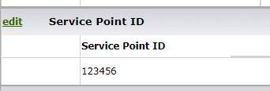

Rent Assistance Payment and Services Plan Control

Once the Hub approves rent assistance, the Hub staff must complete the Rent Assistance Payment and Services Plan Control to document and track what Funding Source and Payment Type are approved for the participant. If the participant will be served by multiple funding sources, the Hub must enter one plan for each funding source. See the Rent Assistance Regional Program Standards for definitions of payment types. The records are updated to extend Target End Date or set an End Date. When payments end, Hub staff must enter Housing Status at Funding End.

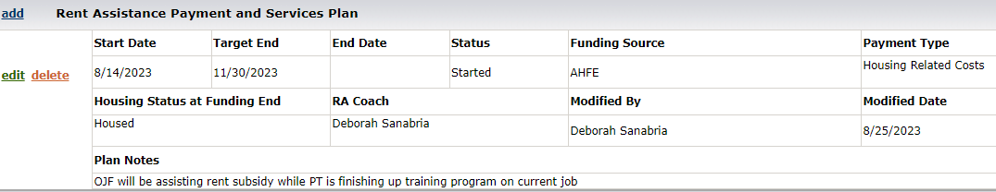

Rent Assistance Payments Control

The Hub enters the payment information in the Rent Assistance Payments Control for each month of rent assistance payments and each time a payment is made for a participant. See the Rent Assistance Regional Program Standards for payment type definitions.

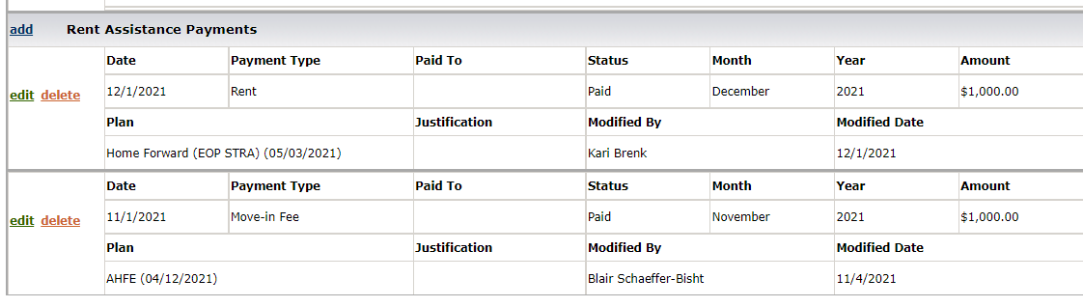

Outcomes Tab for Hub Staff

The following Hub contract performance measures are tracked in I-Trac and ServicePoint.

HUB MEASURES | OUTCOMES
Housing Supports | Number of participants provided with Rapid Rehousing or Homelessness Prevention services.
Housing Retention | Percent of participants who received Rapid Rehousing or Homelessness Prevention services that retain housing for 6 months (after financial assistance ends).
 | Percent of participants who received Rapid Rehousing or Homelessness Prevention services that retain housing for 12 months (after financial assistance ends).

Program Status Control

The first two program statuses are entered by the Hub as appropriate.

- Pre-Program Exit: Hub staff manually enter this status when a referral is initiated and the participant is not accepted into the program. A Pre-Program Exit will full program exit the record and remove it from all performance. Pre-Program Status is automated by the system when the participant is not approved within 45 days of the Application date. Hub Staff must also add a case note with an explanation of why the referral was not accepted.

- Exit: Hub staff manually enter this status when the participant has ended rent assistance after all funding sources are ended for support of rent assistance. Exit date is the date of the last hub service. Typically, this is the last day of the last month when the hub paid the rent. Staff need to enter the final service of “Hub Final Rent Exit“ on the Services Tab before entering this “Exit” status on the Outcomes Tab.

NOTE: When a participant has exited and then returns AFTER 90 days needing rent assistance, a new Rent Assistance record must be created for the participant by the Career Coach.

If participant returns for additional rent assistance within the 90 days of program exit, Hub Staff contact their Worksystems Contract Manager to have the exit removed and continue entering services and payments into the same record.

The following status will occur if the housing Hub does not enter data as required.

- Auto Exit: This status will auto populate if a record goes more than 90 days without a service entered. Worksystems staff may remove an Exit if data is missed being entered within the 90 day window.

Rent Assistance Outcomes Control

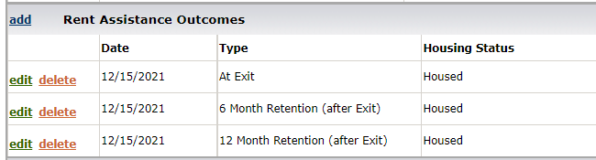

Hub staff will enter the following outcomes in this control:
- Type – Choose the type that corresponds to the correct point in time:
- At Exit- Select at the point of Exit when rent assistance has ended for a participant in all funding sources.
- 6 Month Retention (After Exit)- Select when it has been a full 6 months since rent assistance ended for a participant. Do not input retention data if the participant was not housed when rent assistance ended.
- 12 Month Retention (After Exit)- Select when it has been a full 12 months since rent assistance ended for a participant. Do not input retention data if the participant was not housed when rent assistance ended.

- Housing Status – Choose the status that explains the participant’s situation at the selected point in time
- Housed
- Not Housed
- Unknown- Select when a participant is unable to be contacted.
- Received RA Again- Select when a participant has exited and returns AFTER 90 days needing rent assistance again. In this case the Career Coach re-enrolls the participant into a new Rent Assistance record and this “Received RA Again” status is entered in the exited Rent Assistance record. When this “Received RA Again” status is entered, the participant’s first enrollment episode outcomes are removed from performance.

Employment Confirmation Control

This control is only capturing UI confirmations. No data is manually entered by staff.

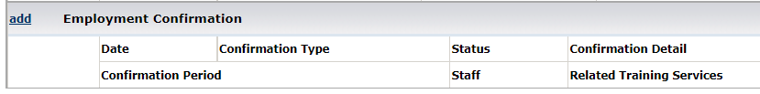

Case Notes Tab for Hub Staff

Narrative case notes are not a service but may be completed in I-Trac to document additional detail around participation activities; successes and challenges; progress towards goals; and performance outcomes. Narrative case notes should not repeat information already entered in the I-Trac system, but expand upon, provide context to or augment service or employment data.

A case note with an explanation is required when the referral is not accepted by the Hub Staff.

