Service Point Report guidance can be found here. Use Program Performance and Follow ups/Housing Retention reports.

Number of Referrals Received and Accepted
Reporting Element | Definition | How to Pull the Data
Number of referrals received | All referrals submitted to the RA Hub via ITrac | ITrac Standard Reports: Customer Flow - RA Fund  - Choose Rent Assistance Fund & Current Program Year  - Click on View Report button  - Click on Customer Flow & confirm Filters- NONE  - Report the number on ‘Applied’ line for the desired quarter
Number of referrals accepted | All referrals that were accepted by the RA Hub | ITrac Standard Reports: Customer Flow - RA Fund  - Choose Rent Assistance Fund & Current Program Year  - Click on View Report button  - Click on Customer Flow & confirm Filters- NONE  - Report the number on ‘Registered’ line for the reporting quarter
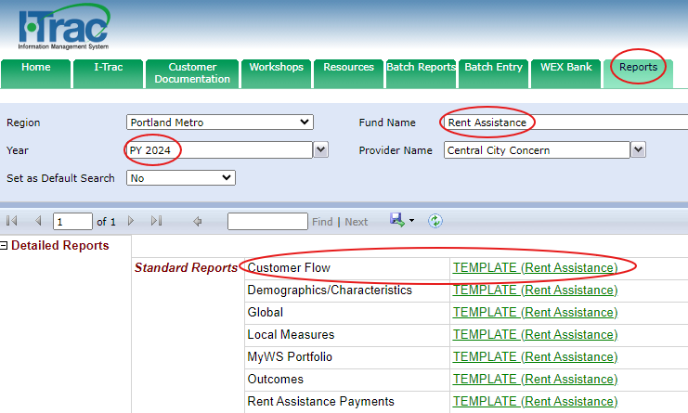

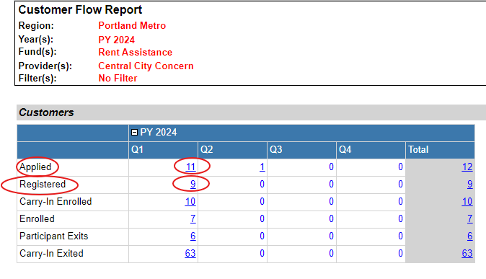

Number of Participants Provided with Housing Placement/Prevention

Reporting Element | Definition | How to Pull the Data
Number of EOP participants provided with housing placement (Rapid Rehousing) | Number of Rapid Rehousing participants who received at least one housing related payment | I-Trac Standard Reports: Rent Assistance Payments- RA Fund  - Choose Rent Assistance Fund & Current Program Year  - Click on View Report button  - Click on Rent Assistance Payments & confirm Filters- NONE  - Go to ‘Rent Assistance Payments’ section  - Click on Rapid Rehousing Total for desired quarter  - Green circle in picture on next page of this guide  - Use reported # of Customers above the list of customers
Number of EOP participants provided with eviction prevention (Homeless Prevention) | Number of Homeless Prevention participants who received at least one housing related payment | I-Trac Standard Reports: Rent Assistance Payments- RA Fund  - Choose Rent Assistance Fund & Current Program Year  - Click on View Report button  - Click on Rent Assistance Payments & confirm Filters- NONE  - Go to ‘Rent Assistance Payments’ section  - Click on Homeless Prevention Total for desired quarter  - Yellow circle in picture on next page of this guide  - Use reported # of Customers above the list of customers
Total unduplicated number of participants provided with housing placement & eviction prevention | Number of Homeless Prevention and Rapid Rehousing participants who received at least one housing related payment | I-Trac Standard Reports: Rent Assistance Payments - RA Fund  - Choose Rent Assistance Fund & Current Program Year  - Click on View Report button  - Click on Rent Assistance Payments & confirm Filters- NONE  - Go to ‘Rent Assistance Payments’ section  - Click on Grand Total for desired quarter  - Blue circle in picture on next page of this guide  - Use reported # of Customers above the list of customers

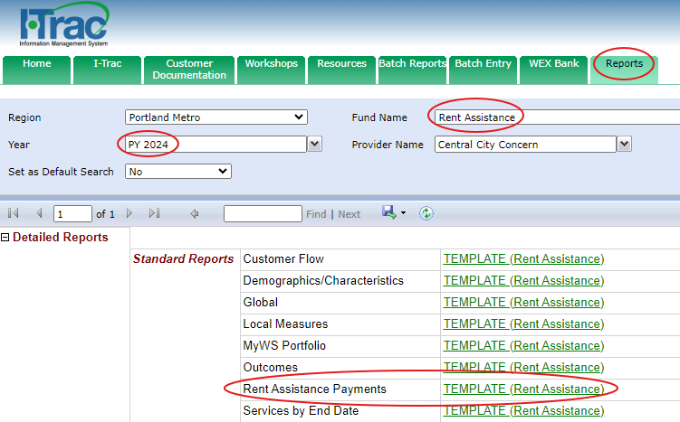

Number of Participants Provided with Housing Placement/Prevention, continued

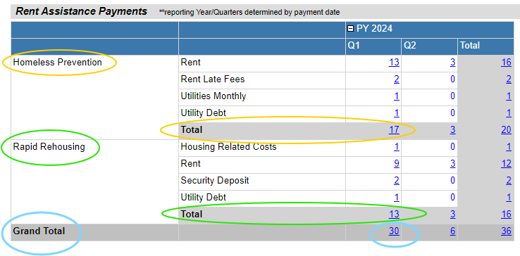

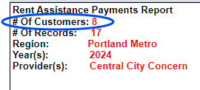

Number of Participants Provided with Housing Placement/Prevention Who Are People of Color
Reporting Element | Definition | How to Pull the Data
Total unduplicated number of participants provided with housing placement & eviction prevention who are People of Color | Number of Homeless Prevention and Rapid Rehousing participants who received at least one housing related payment who are People of Color | I-Trac Standard Reports: Rent Assistance Payments - RA Fund  - Choose Rent Assistance Fund & Current Program Year  - Click on View Report button  - Click on Rent Assistance Payments  - Select Filters- People of Color from dropdown  - Click View Report button  - Go to ‘Rent Assistance Payments’ section  - Click on the Grand Total for the desired quarter  - Use reported # of Customers above the list of customers
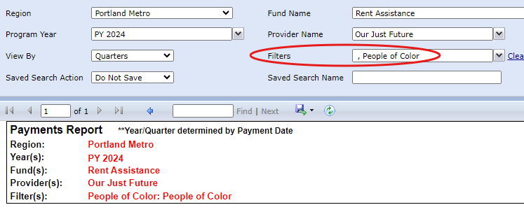

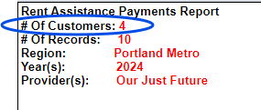
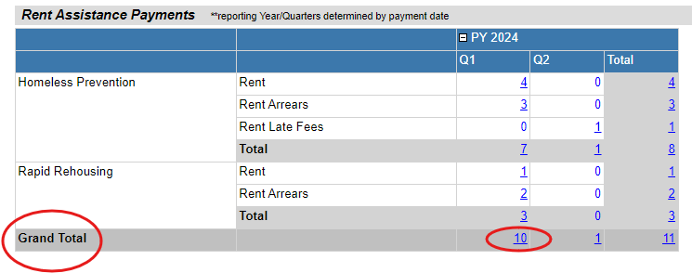

Retained Housing 6 month/12 month After Exit
Reporting Element | Definition | How to Pull the Data
Housing Retention for 6 months after rent assistance ends | Numerator: Participants who are housed 6 months after exit  Denominator: All participants served who were exited 6 months prior that Hub successfully contacted | I-Trac Standard Reports: Local Measures - RA Fund  - Choose Rent Assistance Fund & Current Program Year  - Click on View Report button  - Click on Local Measures & confirm Filters- NONE  - Go to ‘Retained in Housing 6 months after Exit’ section  - Use ‘All Above’ Total % for desired quarter  - Yellow circle in picture on next page of this guide  - Click on ‘All Above’ Total % for desired quarter  - Use reported # Numerator and # Denominator above the list of customers
Housing Retention for 12 months after rent assistance ends | Numerator: Participants who are housed 12 months after exit  Denominator: All participants served who were exited 12 months prior that Hub successfully contacted | I-Trac Standard Reports: Local Measures - RA Fund  - Choose Rent Assistance Fund & Current Program Year  - Click on View Report button  - Click on Local Measures & confirm Filters- NONE  - Go to ‘Retained in Housing 12 months after Exit’ section  - Use ‘All Above’ Total % for desired quarter  - Green circle in picture on next page of this guide  - Click on ‘All Above’ Total % for desired quarter  - Use reported # Numerator and # Denominator above the list of customers

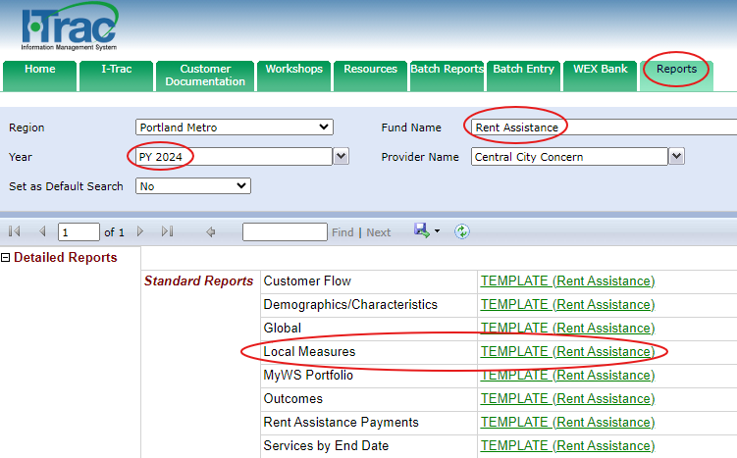

Retained Housing 6 month/12 month After Exit, continued

